Stonycreek River
A New Beginning for an “Old Friend”

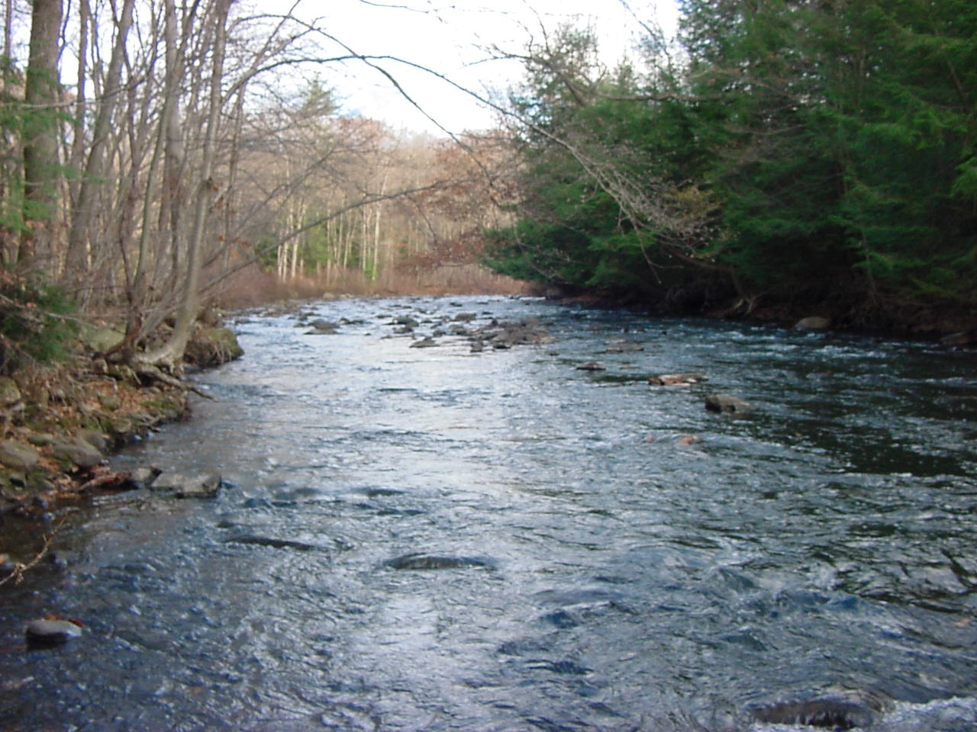
Photo by Lenny Lichvar

From the Upper Gorge down through the Canyon, the Stonycreek River is a scenic, largely wild resource with enormous, untapped potential for recreation. That potentiality is being discovered by fishermen willing to hike into the Upper Gorge in search of holdover trout and canoeists and kayakers who travel to Somerset County from surrounding states to run the Canyon’s whitewater.

Other sections of the river offer scenic water trails for less daring canoeists and a trail for hiking and biking is being expanded along the lower Stonycreek in and near the city of Johnstown. Enthusiasm for the river has grown as efforts to clean up acid-mine drainage progress.

The Stonycreek begins at Pius Springs in Berlin Borough, five miles south of the Pennsylvania Turnpike. The river flows northward for 43 miles, draining 466 square miles in Somerset and Cambria Counties.
At the Point in Johnstown, the Stonycreek joins the Little Conemaugh River to form the Conemaugh River, which flows into the Kiskiminetas River and then into the Allegheny River above Pittsburgh. Shade Creek and another tributary, Rhoads Creek, originate high on the Allegheny Front at elevations above 2,700 feet, while Quemahoning Creek and Bens Creek begin on Laurel Ridge at elevations exceeding 2,600 feet. Some smaller tributaries, such as Wells Creek and Oven Run that begin as abandoned mine discharges and Beaver Dam Creek which flows through pasture land, enter the river as it makes its way to Johnstown, where the elevation is 1,140 feet.

The steepness of the feeder streams and river, evident in the descriptive names, such as the Upper Gorge and the Canyon, are a primary reason that Johnstown has a history of floods. In 1889, 1936 and 1977, the Stonycreek River received ominous notoriety in conjunction with the infamous Johnstown floods.
However, the elevations and gradients of the headwaters also help make many tributaries whitewater boat runs and coldwater fisheries.

In addition to the Stonycreek Gorge; Beaverdam Creek, Beaverdam Run, Bens Creek and the South Fork of Bens Creek are trout fisheries managed by the Pennsylvania Fish and Boat Commission. Clear Shade Creek and its tributaries, Cub Run and Piney Run are excellent trout streams, flowing through the Babcock Division of Gallitzin State Forest. Clear Shade is a popular fishery while Cub Run is more difficult to get to and Piney Run is so isolated that it is classified as a Wild Trout stream by the Fish and Boat Commission.

Thanks to the Jenner Community Sportsmen’s Club Cooperative Trout Nursery and many volunteers the up-stream portion of Quemahoning Creek was first stocked in 1998, and for the first time downstream to the Quemahoning Reservoir in 2005, resurrecting a fishery that had been non-existent for 100 years. Cooperative Nursery fish were also stocked in Wells Creek for the first time in history in 2004, creating yet another fishery in that important tributary.

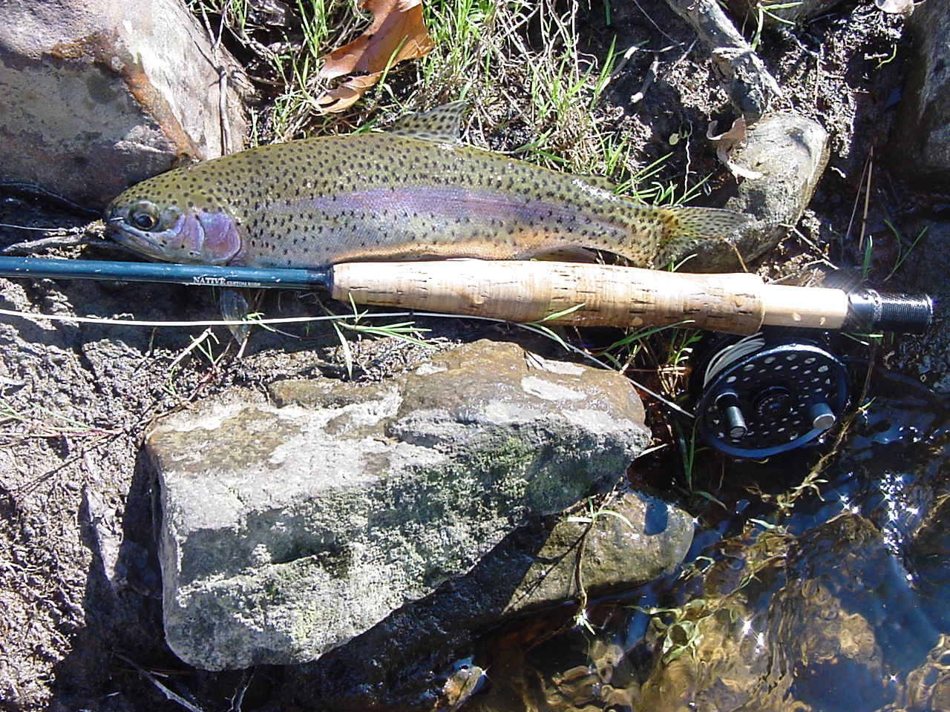
Photo by Lenny Lichvar

When the water levels are high in the spring, canoeists can be found, not only on the main stem of Stonycreek, but also on Shade Creek, Paint Creek and Bens Creek. From its headwaters at Berlin, the river meanders through a high plateau of pastureland for 10 miles until it reaches the historic Glessner Covered Bridge, built in 1881, on Township Road 565, a half mile north of Shanksville. Much of the river in this area lacks vegetative cover and has a low gradient, so fishing here is limited. Over the next nine miles, the river drops 500 feet in elevation through an inaccessible area called the Upper Gorge. This nine mile stretch provides some of the best trout fishing in the region and has been hailed as one of the best reclaimed mine drainage impaired trout fisheries in national publications and books. In 2003 Trout Unlimited Television filmed a show that focused on the recovery of the river and fishery that aired nationally on the Outdoor Life Network.

This classic “freestone” river had benefited from some mine reclamation in the 1970s and 1980s, as well as slow improvement of several feeder streams from natural causes. Fisheries experts believed that the river had an optimum riffle/pool ratio and a wild and scenic nature to give it the potential to become one of the finest sport fisheries in Pennsylvania. The Fish Commission resumed stocking the Gorge in the late 1970s with legal size trout. In the early 1980s, the commission switched to stocking fingerlings only to produce more of a wild-trout character. Commission surveys show that the gorge supports 20 species of fish, including brook, brown and rainbow trout, small mouth, spotted and rock bass. Fishermen report catches of 15 to 18 inch trout.

However, access is limited. The fishery can only be accessed upstream of the Gorge at Shanksville or State Route 1007, which follows the river. The closest access point to the top of the gorge is at Glessner’s covered Bridge on Township Road 565. The only public access to the middle of the Gorge is on Pompey Hill Road near Kimmelton. The lower end of the Gorge can be reached by hiking upstream from another historic covered bridge, the Trostletown Bridge, built in 1845, located on Township Road 647 just south of Route 30. Most of the land along the Stonycreek is privately owned and any public access available is a privilege granted voluntarily by private landowners. As late as 1986, the fishery ended a short distance below Kantner. The Fish and Boat Commission, at the request of a local outdoor writer, stocked 50 smallmouth bass at the 403 bridge below Kantner. The fish reportedly did well but the river was so bad for so long it was considered pointless to add more. With the construction of the six Oven Run passive treatment systems below Kantner, the fishery was extended downstream to the mouth of Shade Creek.
In September of 2001, members of the Stonycreek–Conemaugh River Improvement Project (SCRIP) in cooperation with local sportsmen’s clubs, purchased and stocked 2,400 smallmouth bass from Johnstown to Hooversville. On October 7, 2003, The Fish and Boat Commission stocked 2,900 smallmouth bass in the river. They also stocked smallmouth and rock bass in October of 2004. The agency plans to continue stocking smallmouth each fall. There are still some discharges to be cleaned up but the river is now a viable fishery, with some stretches marginal, for its entire length.
Pokeytown Run is more acidic than vinegar. Iron from this stream continues to stain the rocks of Stonycreek, but with the coming on line of the Oven Run projects the stain has become less pronounced.

The problem still exists, although to a lesser degree. The pH of the water in Pokeytown Run is below 3, with 7 being neutral and anything below 6 being marginal and below 5, unacceptable. Stonycreek, below Oven Run is now in the pH 6 to7 range and is expected to improve with the construction of more passive treatment systems upstream. Hooversville, located downstream from Oven Run benefits to a fair degree from the water quality improvement in that it draws its water supply from Stonycreek. It is also where the best kayaking begins and that is also where the bass fishery begins. The five mile section from Hooversville to Benson is the site of the Benscreek Canoe Club’s annual Stonycreek Rendezvous which, in good years, has drawn over 50 boaters for the April event. This section of the river is a scenic course for intermediate and perhaps novice canoeists because of its Class 2 and occasional Class 3 rapids -higher classes are more dangerous.
The novices take out at Benson because the next five miles can be treacherous. Not far below Benson is the start of the Stonycreek Canyon, one of the most continuous rapid–pool runs in the East with about 20 Class 3 and Class 4 rapids. When the river flow is high, the ratings actually go to the highest rating - Class 5, prompting even the most experienced kayakers to stay of the water. The Canyon drops over 200 feet in elevation in about three miles and is one of the most isolated and gorgeous sections of the river. This was the site of the 1972 Olympics qualifying runs and the site of the annual Stonycreek Race, again sponsored by the Benscreek Canoe Club. The annual event draws whitewater enthusiasts from as far away as North Carolina and Vermont.
Experienced boaters say the Canyon in March and April provides a better run than the Youghiogheny River at Ohiopyle, which is one of most popular rafting and canoeing destinations in the nation and draws two million visitors a year. The Canyon ends at the mouth of Paint Creek on the border of Somerset and Cambria Counties and from there through the city of Johnstown, the Stonycreek provides intermediate and novice canoeing opportunities.
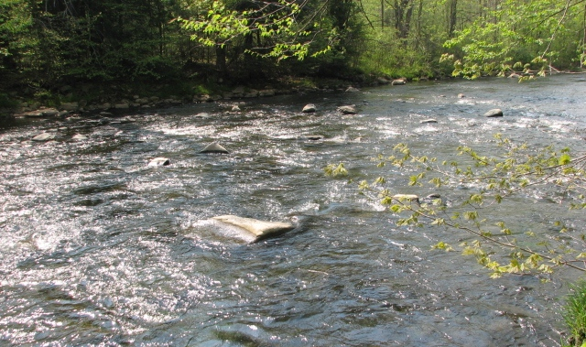
Photo by Lenny Lichvar

The boaters have always been able to tolerate some mine drainage but the fish had a much tougher time. Happily, the constructed treatment systems have helped immensely to change that. After the bass stocking, in which SCRIP took a leading role, the river is on its way to becoming an outstanding smallmouth bass fishery all the way from Hooversville to its confluence with the Little Conemaugh where they join to form the Conemaugh . The water in the lower reaches of the river is too warm for trout but supports panfish and perhaps could support a few muskies to add fishing thrills.
Inside the flood control channels, studies and monitoring by SCRIP showed that the Stonycreek supported a marginal, probably seasonal fishery of acid - tolerant species. At that time (1993), the Corps of Engineers said the river had shown a “dramatic improvement in the water quality” with mean total acidity decreased by at least 80% since 1977. With the addition of 17 passive treatment systems in the watershed, the outlook for Stonycreek is very good indeed.
In an hour of electro-fishing within the Stonycreek’s concrete flood control channels, The Corps counted 260 fish, mostly suckers and perch, plus a few blacknose dace and creek chubs. Since that time, fallfish, walleyes and pickerel have been widely reported by anglers.

The walleyes could have come from Quemahoning Reservoir but the fallfish and pickerel must have been introduced by private individuals since they are not native to the Conemaugh watershed. The Corps said at the time that the step from no fishery to even a marginal seasonal fishery is a major stride. Once a fishery is established it sometimes expands quickly, both in numbers of fish and species of fish which prompted the Corps to predict that demand for access to the river inside the flood-control channels to grow.
Indeed, that has happened. On the edge of the city is the first section of the Rail-Trail to be completed in the basin. The two-mile James E. Mayer Trail is extremely popular with local residents, running between the river and a wooded hillside from the city’s Moxham neighborhood to the village of Riverside in Stonycreek Township. The trail is being expanded through the city and will be linked to the James Wolf Sculpture Trail on the wooded hillside adjacent to the famous Johnstown Inclined Plane which was built after the 1889 flood to provide residents a convenient means of escaping future floods. The Inclined Plane and sections of the Sculpture Trail provide great views of the city looking out across the Stonycreek River. The nine mile Stonycreek Trail will also connect to proposed trails along the Conemaugh and Little Conemaugh Rivers.

All these recreational opportunities are being developed as acid-mine drainage is being cleaned up. SCRIP, The USDA Natural Resources Conservation Service, US Congressman John Murtha, the PA Department of Environmental Protection, and many other partners undertook a $5 million six-site reclamation effort on Oven Run and Pokeytown Run. This effort along with three treatment systems installed along Wells Creek, two on the Quemahoning Creek and one on Higgins Run has extended the fishery all the way to the mouth of the river, with a few exceptions such as the Shade Creek and Paint Creek discharges. Plans are now in the process of being made to treat these pollution sources. When these are cleaned up, the river should be first class. As mentioned, the cleanup has also benefited the Borough of Hooversville by cleaning up their drinking water supply and has made Stonycreek a model for others to use in their efforts to clean up a river.
Three co-generation power plants in Cambria County are burning old coal refuse or “boney” piles, which are a major contributor to acid, iron and other pollutants. The Stonycreek River is a resource offering amazing diversity, ranging from the urban trail development on its lower end to the excellent trout fishery near its headwaters, with highly acclaimed canoe courses and an established panfish and bass fishery in the middle.

JOIN THE STONYCREEK CONEMAUGH
JOIN SCRIP- HELP RESTORE OUR RIVERS!

Name______________________________________
Address____________________________________
City__________________State_____Zip__________
____$15 Individual ____$50 Club/Small Business
____$20 Family ____$100 Sustaining
____$50 Patron ____$500 Sponsor
____$1,000 Advocate
____$6 Student
Make checks payable to “SCRIP” or, to make a tax-deductible contribution, make checks payable to “Southern Alleghenies Conservancy/SCRIP”, and mail the check with this form to SCRIP, P.O. Box 153, Johnstown, PA 15907-0153.

FOUNDATION GIFTS GO ON FOREVER: SCRIP has a fund in the Community Foundation for the Alleghenies. Membership or other contributions may be designated for our Foundation account, where earnings are available annually to benefit or rivers forever.
RIVER IMPROVEMENT PROJECT (SCRIP)

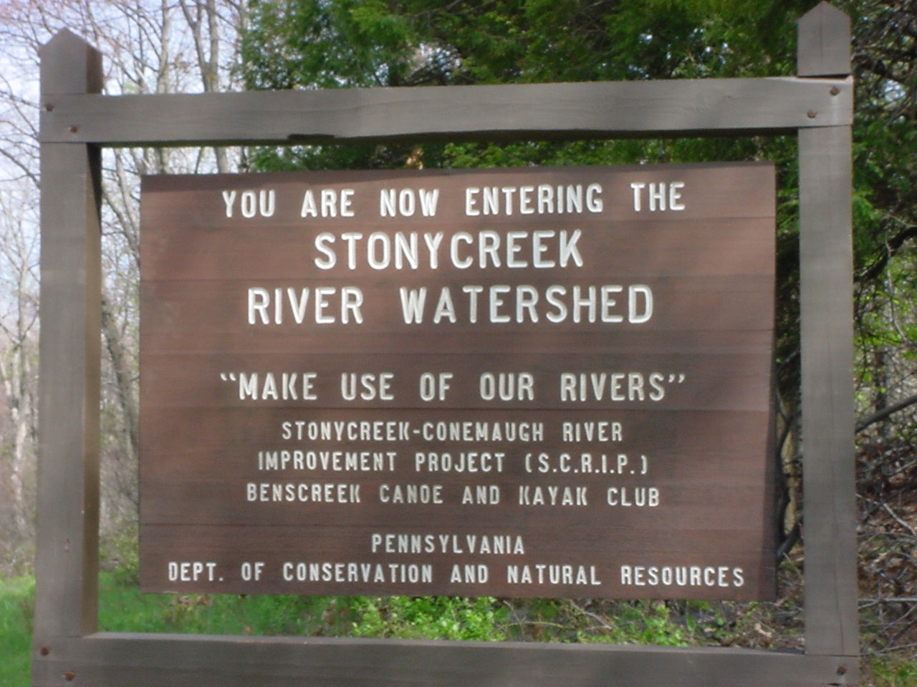
Photo by Lenny Lichvar

Name ______________________________________
Address ____________________________________
City__________________State_____Zip __________

____$6 Student ____$15 Individual ____$20 Family ____$50 Club/Small Business

____$50 Patron ____$100 Sustaining ____$500 Sponsor ____$1,000 Advocate

Your annual membership dollars are used to sustain the effort to improve water quality in the Stonycreek and Little Conemaugh River watersheds and to raise public awareness of the need to restore and protect our precious water resources. Gifts or donations to SCRIP will also be used for the same purpose, and will assist local conservation organizations to achieve their missions.

Please make checks payable to “SCRIP” or, if you would like to make a tax-deductible contribution, please make checks payable to “Southern Alleghenies Conservancy/SCRIP”, and mail the check with this form to SCRIP, P.O. Box 164, Windber, PA 15963.

FOUNDATION GIFTS GO ON FOREVER: SCRIP has an endowment fund in the Community Foundation for the Alleghenies. Membership or other contributions may be designated for our Foundation account, where earnings are available annually to benefit or rivers forever.

MAKE USE OF OUR RIVERS!
www.scrippa.org

