Little Conemaugh River

Raw Recreation Potential and History Deep in Floods, Canals and Coal
____________________________________________________________________________________

High on the Allegheny Ridge, the Little Conemaugh River gets its humble beginnings in a large wetland along Route 22 near Cresson. But in just 29 miles, the river drops over 1500 feet in elevation. Rivers with such steep grades usually offer great recreational opportunities, but recreational use of the Little Conemaugh is severely limited because of acid-mine discharges that seep, flow and sometimes gush as artesian wells, spouting 10 or 15 feet into the air.

Across its drainage area of 188 square miles, the Little Conemaugh also has raw sewage, sediment and industrial waste. But by far the most profound problem is mine drainage—a legacy of coal mining that dates to the 1700s.

Fishing in the watershed is limited to the North Branch, the headwaters of the South Fork, and a handful of feeder streams. Area canoe enthusiasts identify two stretches with boating potential.

Trails are being developed along the entire length of the river to provide a recreational linkage from Allegheny-Portage Railroad National Historic Site to the Johnstown Flood National Historic Site and on to several National Historic Landmarks in Johnstown, where the Little Conemaugh meets the Stonycreek River to form the Conemaugh River. The Conemaugh flows into the Kiskiminetas River and eventually into the Allegheny River above Pittsburgh.

Since the trail will parallel the Little Conemaugh in a corridor expected to attract over a million visitors a year, outdoorsmen, conservationists and local residents who want to improve their quality of life are joining with tourism development groups to promote the river's restoration and recreational development.

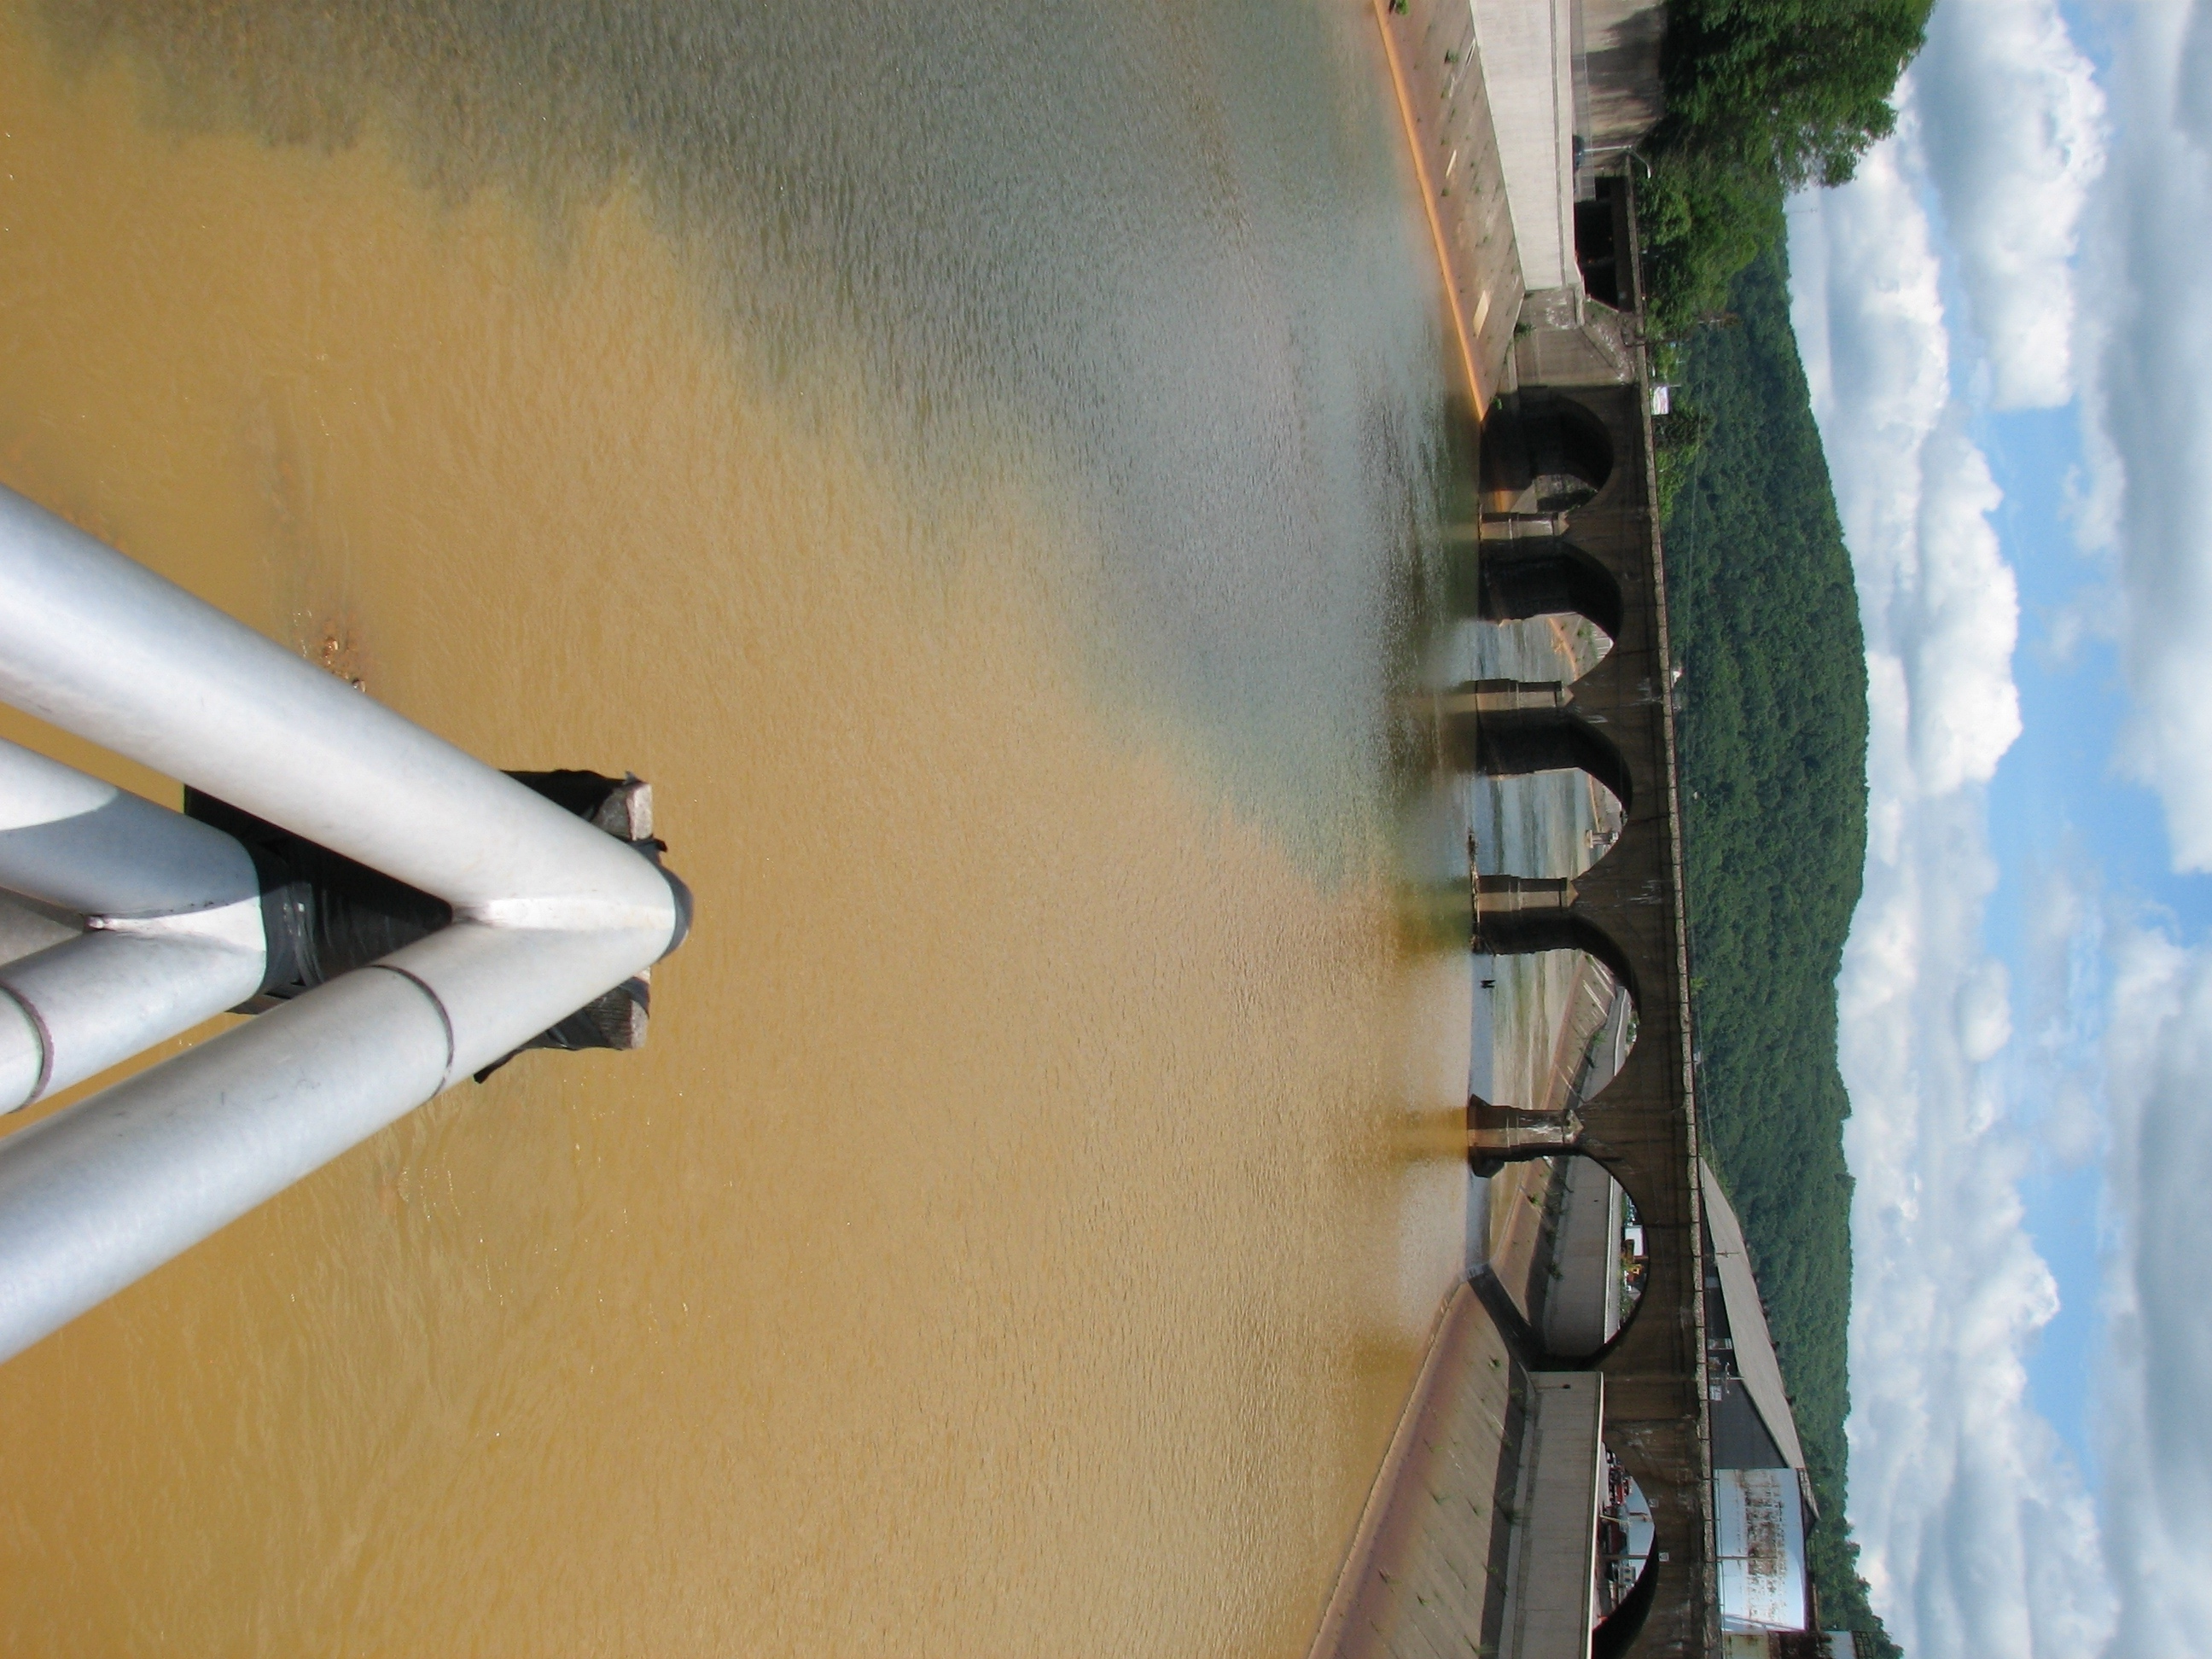
The Little Conemaugh (right) meets the Stonycreek River at the Point in Johnstown to form the Conemaugh River.
Photo by Lenny Lichvar

In his History of Cambria County, published in 1907, Henry Wilson Storey describes the river's South Fork:
”Its waters before the opening of the mines along its branches were as clear as crystal, which even a heavy rainfall on its headwater scarcely clouded, as little land was then cleared in those localities, the water draining principally from a mat of roots and stones and herbage. In these pellucid streams innumerable game fish--especially trout, some of them of prodigious size--were found. Indeed it is doubtful if any other stream of equal size in Pennsylvania has produced so many millions of speckled beauties as the South Fork and its branches.”

Fishermen came by train from Pittsburgh and Philadelphia to enjoy the spectacular trout fishing on the South Fork. A contributing factor to the 1889 collapse of the South Fork Dam was the debris that had caught in a screen the South Fork Hunting & Fishing

Club had placed on the dam's spillway to prevent fish from escaping into the river.

The Little Conemaugh Valley's steep topography did not encourage early farmers, and the valley was seldom used even by the Indians.

One of the earliest visits from a European to the Little Conemaugh is recorded in the journal of the French trapper and Indian trader James LeTort, who wrote that he had traveled down a river known as the Little Otter in 1731 and traded with Delaware Indians, who had a village near the junction of the "Little Otter" (Little Conemaugh) and the "Sinnahanna" (Stonycreek)—now the site of Johnstown. Similar visits were reported by Conrad Weiser, an Indian agent, and Christopher Gist, a friend of George Washington.

But there was little settlement along the Little Conemaugh and even Conemaugh. Old Town, the Indian village visited by James LeTort, was found abandoned by subsequent visitors. Without the rich farmland found to the south along the Stonycreek, the area had little to attract either Indians or whites.

In 1768, the Treaty of Fort Stanwix opened the Allegheny Wilderness to white settlement. In 1769, Samuel, Rachel and Solomon Adams settled near current-day Elton, and Solomon build a grist mill along the run that bears his name. In 1801, the Croyle family dammed the Little Conemaugh at Summerhill to power a grist mill, which operated into the 20th Century.

Many early settlers made their livelihood by cutting trees and building rafts to float goods downriver to sell in Pittsburgh (including the timber in the rafts). Until the discovery of mineral wealth and construction of reliable transportation, the hills surrounding the Little Conemaugh were largely uninhabited by humans. Exploitation of the vast coal reserves that lay under nearly all of Cambria County was the death of the Little Conemaugh. Although written records of coal around Johnstown date to 1788, the first commercial production in the area reportedly came from a mine opened near Lilly in 1825 by Matthew and Michael Myers, who sent the coal east by packhorse to blacksmiths in the iron-working area of the Juniata River valley.

Moving coal and other goods became much easier when the cross-state Pennsylvania Canal and Allegheny Portage Railroad opened in 1834 to transport boats over the Allegheny Front. Johnstown grew quickly from a frontier settlement into a bustling city. Small villages sprouted almost overnight up and down the rail line along the Little Conemaugh and the efficient transportation made it economically feasible to manufacture goods that could be shipped elsewhere for sale.

Canoeing potential...
Area canoe enthusiasts identify two stretches of the Little Conemaugh River that have boating potential. The section from Wilmore to Summerhill is a pretty and isolated stretch without too many rapids, and maintains enough flow into the summer for canoing. From Summerhill to South Fork, the river tends to be too rocky and shallow, but from South Fork to Mineral Point, the Little Conemaugh offers a nice whitewater run with Class 3 rapids. This stretch, described as isolated and beautiful, goes around a two-mile oxbow and passes through the narrow gorge where, in 1889, a 75-foot-high railroad viaduct momentarily withstood the raging waters of South Fork Dam. About half-way between Mineral Point and East Conemaugh, however, is an extremely dangerous rapid—a legacy to the area's industrial past. Another large meander in the river was eliminated by Bethlehem Steel Corp. by blasting out rocks to create a new, straighter course for the river. The ravine along the former meander then was filled with industrial waste. The blasted area is dangerous. The LittleConemaugh's main tributary, the South Fork of the Little Conemaugh, also has sufficient flow for paddling in its lower reaches.

The canal consisted of a series of locks and dams and slackwater pools, impoundments built across the river where boat channels could not be dug. Travelers praised the beauty of these "mountain lakes," but the slackwater dams destroyed the habitat of many aquatic species.

A total of 35 locks and four slackwater dams blocked the annual migrations of fish species that had made ancestral spawning runs from the larger western rivers to the Conemaugh headwaters.

To provide a steady water supply for the Johnstown canal basin, construction began on the South Fork Reservoir in 1838. When finished in 1852, the 2-mile, 400-acre impoundment was proclaimed the largest man-made lake in the world.

When the Horseshoe Curve enabled steam engines to pull trains over the Allegheny Ridge, the portage rail closed in 1855. The last boat docked at Johnstown on Dec.1 1860 after a tedious and difficult trip through the deteriorating canal.

In 1863, the breast of the forgotten South Fork Reservoir broke, spilling its waters down the Little Conemaugh and damaging the Johnstown canal basin. In 1880, the reservoir was bought by the South Fork Hunting & Fishing Club. Its breast was repaired and it served as a summer resort for wealthy Pittsburgh industrialists.

On May 31, 1889, the dam broke again, unleashing one of the most famous and destructive floods in world history.

Despite the demise of the Pennsylvania Canal and Allegheny Portage Railroad, the river remained an important transportation route. Stapple Bend Tunnel above East Conemaugh, now a National Landmark, was the world's first railroad tunnel and will be a feature of the Path of the Flood Trail. The Pennsylvania Railroad Mainline still follows the Little Conemaugh corridor today.

The establishment and continuation of good transportation stimulated industrial growth, especially steelmaking and coal mining. With several coal seams under Cambria County, the Cambria Iron Company was created in Johnstown in the 1850s, and by the 1880s was the world's leading producer of rails, playing a key role in the opening of the American West. Mines and mining communities spread from Johnstown up the Little Conemaugh basin and into the countryside.
Because much of the coal in the Little Conemaugh watershed was systematically mined by a few coal companies controlled by big steel interests, most of the deep mines were interconnected and flooding problems in one mine could be solved by diverting flow to adjoining exhausted mines. Consequently, mine discharges in the Little Conemaugh watershed are often quite large.

The Hughes Borehole below Lilly, for instance, flows over 800 gallons per minute during low flow. In high spring flows, it becomes an artesian well, spewing acid water 15 feet in the air at a rate of 3,500 gallons per minute. About 30 acres are a wasteland of iron deposits that are several feet thick. Ten other discharges of similar magnitude befoul the Little Conemaugh, including major flows near Lilly, Portage, South Fork and Saint Michael.

By contrast, the larger Stonycreek River basin has only two discharges of this magnitude, which pose major technical and financial challenges to restoration efforts led by the Stonycreek-Conemaugh River Improvement Project (SCRIP).

A bright spot for the Little Conemaugh is development of cogeneration facilities in Cambria County. Co-Gen plants burn coal refuse, called "boney," to generate electricity. Many large boney piles are major sources of acid and iron in the waterways.

Fish and wildlife do occupy pockets of habitat on several Little Conemaugh tributaries. There were beaver and high value wetlands in the headwaters and Kokomo Run. Ben's Creek, Howell's Run, Big Laurel Run, Noel's Run and the North Branch and South Fork of the Little Conemaugh are stocked with trout by the Pennsylvania Fish & Boat Commission.

A clean Little Conemaugh would provide much-needed outdoor recreation while providing a tremendous boost to the area's growing tourism industry.

