Shade Creek

Finest Native Trout Streams and Largest Mine Discharges
____________________________________________________________________________________

The Shade Creek sub-basin of the Stonycreek River is a microcosm of all problems and opportunities offered by the waterways of Southwestern Pennsylvania. Shade Creek drains 98.4 square miles, with many of its feeder streams beginning high on the Allegheny Ridge in Somerset County along the border with Bedford County.

But while its northern tributary, Clear Shade Creek, offers some of the finest native, reproducing trout streams in the region, its southern tributary, Dark Shade Creek, has the two largest abandoned-mine discharges and some of the worst water quality in the entire Stonycreek River watershed.

Consider the resources:
*Canoeists and kayakers run the lower reaches of Clear Shade and, despite the pollution, run Dark Shade and Shade Creeks in the spring and other periods of high run-off. The last 2 miles of Dark Shade are a very steep, dangerous course, which, in the region, is considered second only to Paint Creek in difficulty. In canoeists lingo, this section has Class 4 and 5 rapids, and Class 5 is the highest, most dangerous classification. The last 3 miles of Clear Shade from Windber Reservoir to its mouth near Route 160 is another very challenging course of Class 4 whitewater, and the mainstem Shade Creek offers an II-mile solid Class 3 run.

*Clear Shade Creek is one of the region's best trout fisheries and the only stream in the Stonycreek-Conemaugh Basin that has a Fly Fishing Only section. One of its tributaries, Piney Run, is classified by the Pennsylvania Fish & Boat Commission as a Wild Trout Stream because it flows through isolated

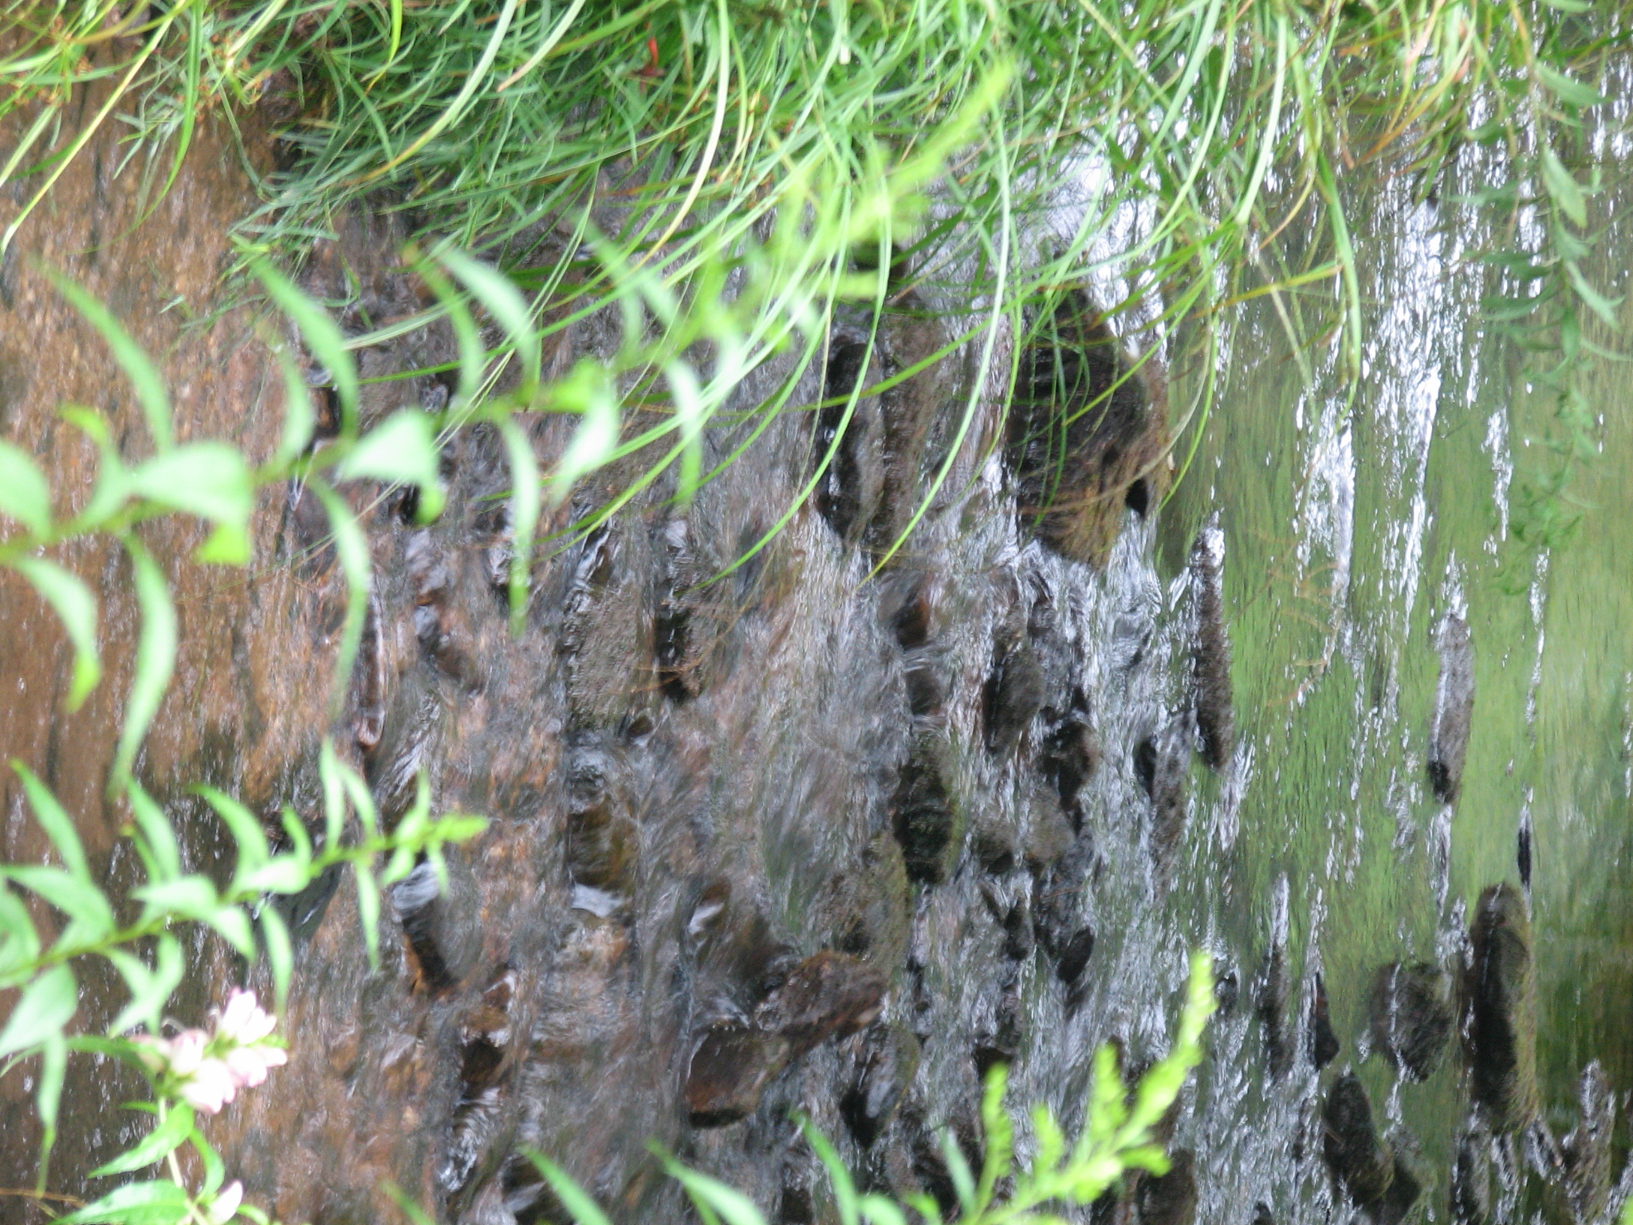
Clear Shade Creek, a tributary to Shade Creek is still a viable coldwater trout fishery.
Photo by Lenny Lichvar

private forest land. And both Piney Run and Cub Run contain native, reproducing brown and brook trout. Dark Shade Creek could rival its sister stream as a fishery. A feeder stream, Little Dark Shade, supports stocked trout and another, Beaverdam Run, has reproducing trout. But Dark Shade Creek, impacted by a century of pre-regulatory mining, is among the most acidic streams of comparable size in the Conemaugh River Basin, the Army Corps of Engineers found in a Basin Study. Dark Shade's impact is obvious far down stream. Shade Creek entering the Stonycreek River near Seanor can be as acidic as vinegar, and Shade and Dark Shade are nearly devoid of aquatic invertebrates, such as insects. That sterile, polluted environment is especially tragic when juxtaposed against Clear Shade Creek and its tributaries.

Clear Shade begins in Gallitzin State Forest in the extreme northeast corner of Somerset County, high on Allegheny Ridge at an elevation of 2700 feet above sea level. Feeders Cub Run and Piney Run also originate on Allegheny Ridge, which is the highest ridge formation in Pennsylvania.

This ridge is a unique, geological boundary, also called the Allegheny Front, which marks the dividing line between the Appalachian Plateau Province to the west and the Ridge and Valley Province, which stretches eastward to Central Pennsylvania. Temperatures are cooler on the ridge and the growing season is two to four weeks shorter than in areas of Bedford County just three or four miles to the east. The weather is unpredictable and often severe, especially in the winter.

Clear Shade flows through Ogletown, passes under Route 56, and re-enters the State Forest in an area designated Clear Shade Wild Area.

The State Forest features several trails, which are also popular among cross-country skiers. The John P. Saylor Memorial Trail has a 12-mile northern loop and 6-mile southern loop that encompasses the Wild Area. The loops are joined by an 80-foot swinging foot bridge over Clear Shade Creek. The Bog Path circles a bog-like wetland that formed after Babcock Lumber Co. clear-cut the area at the turn of the century and the site became saturated because the old logging railroad beds cut off the natural drainage. Another trail, Boulder Trail, leads to Wolf Rocks, which jut out 20 and 30 feet high. And from Clear Shade Road, Fishermen's Path is a 1/4-mile trail providing access to Clear Shade Creek in the Wild Area.

Clear Shade Creek is stocked by the Pennsylvania Fish & Boat Commission (PFBC) and Windber Sportsmen's Club. It is widely acclaimed as one of the region's best trout fisheries, and a mile upstream of Windber Reservoir is designated for fly fishing only.

Soon after leaving the State Forest, Clear Shade is joined by Cub Run and just below Windber Reservoir by Piney Run. The PFBC describes Cub Run as "a totally remote tributary" in a heavy beech oak forest covered by a rhododendron canopy. The PFBC says of Cub Run, "The invertebrates were extremely diverse and very numerous. Fishes included brown trout, brook trout and sculpin. Brown trout and brook trout are both reproducing." The PFBC describes Piney Run virtually the same way.
Historic Swamp and Mines
The earliest, most celebrated settlement on Shade Creek was at a wetland near Cairnbrook known as Edmund's Swamp. A trading post built there by Edmund Cartlidge in 1745 was the first area landmark noted on maps. In 1758, Colonel Bouquet's forces built a fort in Edmund's Swamp in advance of General Forbes' expedition to attack Fort Duquesne during the French and Indian War. The fort was a stopping point for civilian and military travelers, and a few hunters and farmers settled the area. Industrialization came in 1800, when a sawmill was built on Little Shade Creek. In 1807, an iron furnace built on Shade Creek was the first in Somerset County and reputedly the first west of Allegheny Ridge. The success of Shade Furnace led to the construction of Shade Forge in 1820 and Rockingham Furnace in 1841. Wolf hunter William Oldham built a water-powered grist mill on Shade tributary Piney Run in 1833. Others were erected on Miller Run in 1822 and Dark Shade Creek in 1814 and 1840. Fireclay was mined as early as 1909 and clay was strip-mined near Central City to the mid-50s. Sandstone quarries and natural gas wells extracted minerals, but the wealthiest mineral in the Shade Creek watershed was coal. From when the first coal mine opened in 1820 on Little Shade Creek to the 1980s, coal mining was the largest industry. Area geology formed widespread outcroppings of coal, allowing many farmers to operate small mines during the winter to supplement their incomes by selling the fuel for home heating. In contrast to the one-man operations, Loyalhanna Coal and Coke Co. opened coal mines near Cairnbrook in 1912 and 1919. Reitz Coal Co. opened several in the Central City area in 1916. In 1943, strip mining came to the watershed with the opening of a mine on Laurel Run north of Central City. Most of the Clear Shade drainage area was spared the ravages of mining because of the Windber Water Authority's reservoir, built in 1907 two miles upstream from Clear Shade's confluence with Shade Creek.

Naturally reproducing trout here are

characterized by slow growth and a low percentage of legal fish (less than 10% are over 7 inches long). But trout observed in the PFBC survey ranged up to 14 inches in length—a nice size for a small, headwater stream.

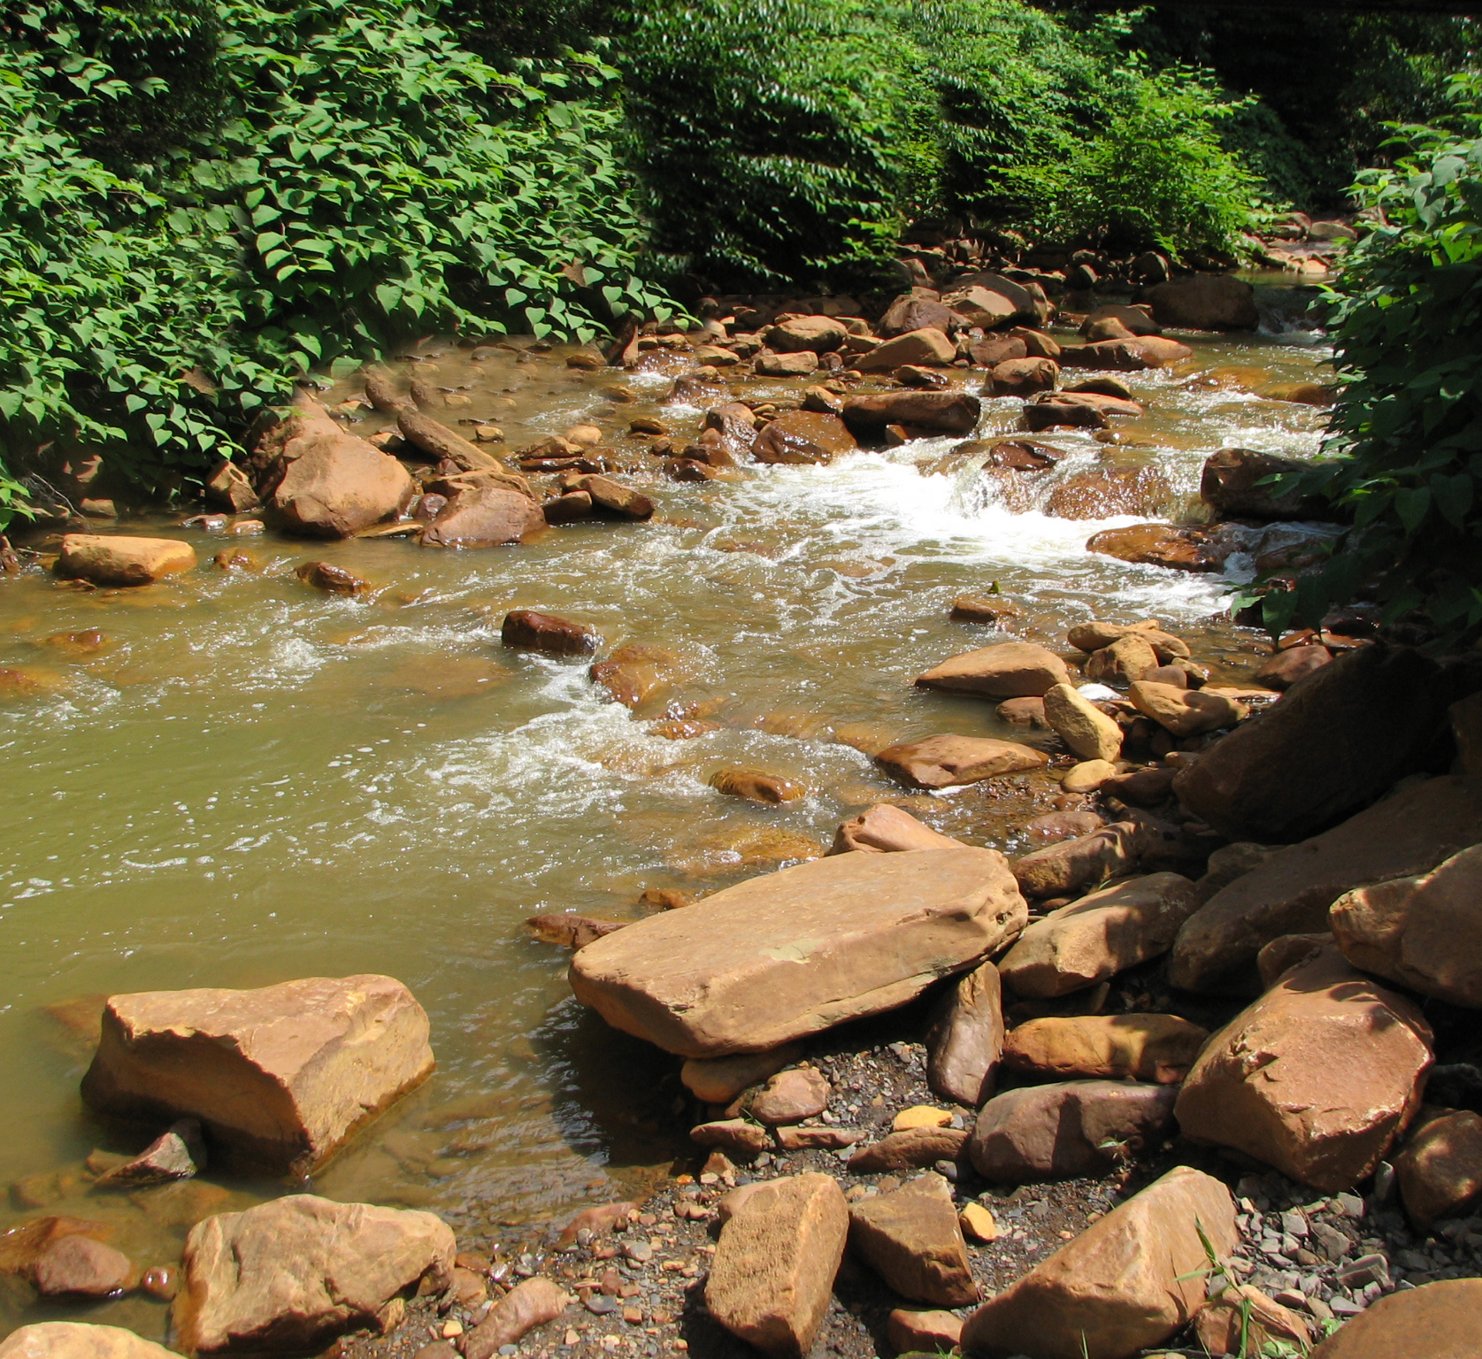
Dark Shade Creek, a tributary to Shade Creek has some of the poorest water quality in the entire Stonycreek River watershed.
Photo by Lenny Lichvar

The problem for these streams is not the mine drainage that destroys many area waterways, but acid precipitation. Pennsylvania's rain and snow is many times more acidic than neutral water. Underlying rocks on Allegheny Front are primarily conglomerate, sandstone and shale, which produce no alkalinity to buffer or neutralize acid precipitation. Because the ridge is so high, it gets more precipitation than surrounding areas, both in summer and winter. The streams tend to be slightly acidic in the best of times (pH about 6.3) and, during spring snowmelt can be as acidic as orange juice (pH of 4.5).

These acidic conditions limit the invertebrates (such as insects) that live in the water, and since fish eat invertebrates, acidity impacts the growth of fish. Trout also are a highly sensitive fish species, and the PFBC says these streams "should be considered fragile."

While the upper part of Piney Run is classified as an Exceptional Value Cold Water Fishery, the PFBC has recommended that the entire length of Cub Run and Piney Run be upgraded to Exceptional Value, which affords higher protection.

Solving the problems on Dark Shade Creek will be far, far more difficult. Studies initiated through the efforts of Stonycreek-Conemaugh River Improvement Project (SCRIP) identified and analyzed all abandoned-mine discharges in the 466 square mile Stonycreek River basin. The two largest flows from old mines are both in the Dark Shade sub-basin.

One discharge near Central City gushes 2,250 gallons per minute of water that's more acidic than vinegar (pH 3.3), making it arguably the worst discharge in the entire Stonycreek Basin. Another runs at 1,780 gallons per minute of water that's not as acidic but does have high iron concentrations.

The impact of these and many other abandoned mine discharges essentially destroys aquatic life in both Dark Shade and its receiving stream, Shade Creek. Dark Shade Creek at Reitz had the second-highest concentration of iron of 38 Stonycreek basin sampling stations in the Army Corps study—23, 150 micrograms in each liter of water.

Dark Shade could be the next target for a major remediation effort by SCRIP. Such an endeavor would potentially restore several miles of Dark Shade Creek and 11 miles of Shade Creek, which would enhance the canoeing and, if fully successful, create new fishing opportunities.

Perhaps even more dramatic is the impact such a project could have on the mainstem of the Stonycreek River. SCRIP has worked with the Natural Resources Conservation Service, PA Department of Environmental Resources and other partners on a major project to clean up six mine discharges on Oven Run, which enters the Stonycreek River about 7 miles upstream of Shade Creek. A similar effort on Shade Creek might enable the establishment of a bass fishery on the Stonycreek into the City of Johnstown.

