Quemahoning Creek

A Watershed With a Storied Past and a Solid Future
____________________________________________________________________________________

Quemahoning Creek has had both a storied past coupled with a history of use and abuse. Artifacts recently unearthed at a rock shelter less than a mile from Quemahoning Creek document human habitation in the watershed dating back several thousand years. The word Quemahoning itself is a Native American word meaning a “Lick in the Pines.” Colonel George Washington along with General John Forbes and their troops crossed Quemahoning Creek in the 1750’s. Literally thousands followed the army’s route, as the Forbes Road was a primary path for westward expansion with settlers heading for new horizons in their Conestoga wagons.

At the turn of the 20th Century, as the extensive coal reserves were beginning to be located and subsequently mined to fuel America’s burgeoning thirst for steam power, the Quemahoning Creek watershed provided the water needs for the coal patch towns and the mining complexes that sprang up along its banks. The world’s largest viaduct and coal tipple, constructed by the Merchant’s Coal Company, spanned Quemahoning Creek at Boswell from 1902 to 1939.

The coal industry that dominated the bituminous coal region in the first half of the 20th Century provided jobs, established rich ethnic heritages, created wealth and provided the fuel that built the infrastructure of the United States. On the down side the unregulated mining had an impact on land and water resources with the subsequent creation of abandoned mine drainage. Quemahoning Creek turned orange as its fish and aquatic life were smothered and killed.
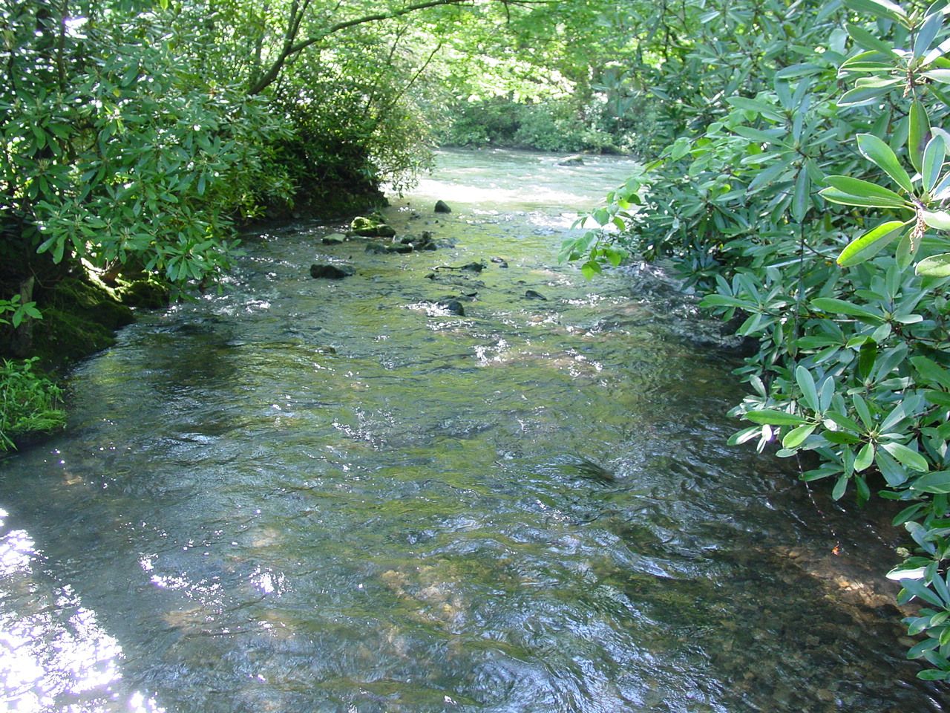

This impact has been a far too long lasting impression in the watershed and has hindered both recreation and economic growth for decades.

Quemahoning Creek is situated in the northwest quadrant of Somerset County flowing along the eastern edge of the Laurel Ridge. The watershed drains approximately 98 square miles with the South Branch originating near Husband in Lincoln Township. The North Branch begins in the lowlands along the Laurel Ridge. Both branches flow northeastward where they meet near Coal Junction in Jenner Township to form the main stem. The Quemahoning Creek continues its journey until it meets the Stonycreek River near Benson Borough in Conemaugh Township.

Quemahoning Creek is listed as a coldwater fishery by the PA Department of Environmental Protection (DEP). However, the South Branch has a low gradient and is a slow moving stream with little canopy.
The North Branch possesses both a higher gradient and more forest cover, as do the naturally acidic tributaries of Beams and Spruce Runs as they all come off the Laurel Ridge.

The main stem itself exhibits low gradient characteristics until just downstream of Boswell where the final four miles drop much faster with a forest canopy habitat, which is more typical for a cold-water stream.

Abandoned mine drainage (AMD) is not the only water quality problem, but it is by far the most severe. In 1994, with AMD abatement efforts already underway in the Stonycreek watershed Len Lichvar, Stream Improvement chairman for the Mountain Laurel Chapter of Trout Unlimited (MLTU) and Stonycreek-Conemaugh River Improvement Project (SCRIP) board member, approached the TU chapter to become the local sponsor of an initiative to begin a comprehensive cleanup of the watershed.

With the backing of MLTU the concept was presented to the Somerset Conservation District, which in turn moved it on to for adoption, by the Southern Alleghenies Resource Conservation & Development Council as a formal project. With the galvanized support of these agencies and organizations in place as well as data available regarding the location and severity of AMD discharges the stage was set to begin the first phase of pollution abatement in the watershed.

In 1995 the U.S. Geological Survey completed a report that documented, located and sampled all the AMD discharges in the Stonycreek watershed including the Quemahoning Creek. The Pennsylvania Department of Environmental Protection made additional documentation available and in 1996 the Conservation District began sampling 20 sites in the watershed.

Also in 1996 the Pennsylvania Fish and Boat Commission conducted a fish survey of the watershed and the PA DEP performed a macroinvertebrate survey that provided valuable base line data on the health of the aquatic ecosystem. These studies confirmed the impairment of aquatic life that matched the water quality problems previously identified.

As this information was gathered the federal Office of Surface Mining (OSM) in cooperation with the Environmental Protection Agency (EPA) combined to create the Appalachian Clean Streams Initiative (ACSI) to assist in funding on the ground AMD treatment systems. With the assistance of U.S. Congressman John Murtha of Johnstown funding from the ACSI as well as from the EPA Regional Geographic Initiative was directed toward Quemahoning Creek. An AMD discharge located on property owned by the Municipal Water Authority of the Township of Jenner in the village of Jenners was identified as an abatement site.

Through the cooperative efforts of the Southern Alleghenies Conservancy’s Survey and Design Team, the PA Mountain Service Corps (Ameri-Corps) and the USDA Natural Resources Conservation Service (NRCS) technical field office in Somerset, a design for the first ever AMD passive treatment system in the Quemahoning Creek watershed was completed in 1997 at a cost of $175,000.

U.S. Secretary of the Interior Bruce Babbitt, who visited the site, proclaimed the water quality improvement efforts occurring in the region as “among the finest in the nation.” With the success of the Jenners Passive Treatment System a second site a mile downstream has been targeted for construction of the next AMD treatment system. A 25 acre site located in Jennerstown Borough was purchased by the Somerset County Conservancy through a $25,000 grant donated by the Jenner Rod and Gun Club. The Somerset Conservation District and Southern Alleghenies Conservancy obtained funding in the amount of $547,000.00 through the Pennsylvania DEP and OSM. Construction began in 2002. Each year, 160 tons of iron will be removed from Quemahoning Creek as a result of this innovative project partnership.

A 1994 report entitled,“Assessment of Non Point Source pollution in the Stonycreek and Little Conemagh Watersheds” was produced by the Cambria County Conservation District in cooperation with the Somerset Conservation District and PA DEP with funding provided through the EPA Region III. This report documented the negative impacts of nutrient and sediment pollution in the watershed. In order to address this component of the comprehensive cleanup the Somerset Conservation District applied for and received $225,000 from the Pennsylvania Growing Greener Grant program to designate a Geographic Priority for the Stonycreek River Basin. The goal of the program is to reduce the total loading of agricultural non-point sourced sediment pollution. This will be accomplished through cooperative efforts with landowners to plan, design and install Best Management Practices (BMP’s). With the North Branch and main stem of Quemahoning Creek identified as highest priorities the district is now working with a dozen landowners to develop management plans and recommend BMP’s, which will reduce the sediment problems in the watershed.

In addition, the Somerset Conservation District received a $60,000 grant from the PA DEP to stabilize a mile section of Quemahoning Creek that has been severely eroded. This project began in 2000 and was completed in 2001. The Jenner Township Board of Supervisors has provided $25,000 worth of in-kind services toward the project. Alkaline materials were used to stabilize the stream bank and at the same time counteract the acidic impacts of AMD. The importance of the major focus of interest and funding in the Quemahoning Creek watershed has been magnified by the recent public acquisition of the Manufacturers Water Company by the Cambria-Somerset Authority.

This historic public acquisition encompasses five water reservoirs including the Quemahoning Reservoir that is located on Quemahoning Creek one mile upstream from its confluence with the Stonycreek. The PA Department of Conservation and Natural Resources (DCNR) contributed $50,000 for a feasibility study to determine whether or not a public acquisition was obtainable. The DCNR also granted an additional 1.5 million dollars toward the acquisition cost which was the largest such grant ever awarded by the department. The Quemahoning Reservoir, will provide potable water supplies for other communities in Somerset County, and previously non-existent, public recreational opportunities.

The impetus to improve the water quality in the Quemahoning watershed in order to help make these additional uses possible has now provided added emphasis for the continuation and expansion of the cleanup.
This cleanup is also coinciding with complimentary local citizen driven initiatives. The Boswell Area Jaycees and the Boswell Lions Club have combined efforts to fund and construct a public recreation park along the banks of the creek.

The Boswell Area Historical Society recently opened their Orenda Park in Boswell along the banks of the Quemahoning. This park provides a walking trail, picnic area and historic interpretive signage. The Society has expended $15,000 worth of locally raised funds and local service organizations have contributed another $15,000 in in-kind services. Both parks provide public access for canoes, kayaks and fishing. For the first time in two generations, anglers are fishing and catching trout in Quemahoning Creek. In addition to the AMD and sediment pollution control projects, a multi-million dollar sewage treatment project has now been completed in the watershed. This project has eliminated raw sewage from entering Quemahoning Creek from upstream communities such as Acosta.

In order to guide the continued work occurring in the watershed the Pennsylvania DEP has contributed $12,500.00 of funding to the Southern Alleghenies Conservancy to create a Comprehensive Watershed Restoration Plan for the watershed. The Western PA Watershed Protection Program also contributed $10,000 to the planning effort. This completed plan sets the stage and direction for continued pollution abatement in the watershed.

Unfortunately, Quemahoning Creek is a typical example of the degradation of our natural resources that has been all too prevalent in the bituminous coal fields of the Appalachian region. Fortunately, the Quemahoning Creek watershed has also been the recipient of what is becoming the typical partnering of local citizens, sportsmen, agencies, organizations and elected officials to correct the resource problems of the past and wisely conserve and enhance our resources for the future.

