Oven Run

A Watershed on The Way To Recovery
_____________________________________________________________________________________

Oven Run, located in Shade Township Somerset County, derived its name from an old stone and clay bake oven that was used by the troops commanded by General Forbes to provide bread for the soldiers during the French and Indian War. A fort was also constructed near the confluence of Oven Run and the Stonycreek River in 1758. The fort was constructed by troops under the command of Colonel Henry Bouquet on land owned by Daniel Berkebile. It was called Fort Belleair as well as Major Jamison’s Redoubt. This fort supported a smaller stockade near the location where the Forbes Road crossed the Stonycreek. These fortifications were also used during the American Revolution. According to verbal history, Indians killed two soldiers as they fished in Oven Run, however, it is not known whether they were British or American.
After the revolution, the first gristmill in Shade Township was constructed along Oven Run. Christian Brallier built it on Daniel Berkebile’s land.

Farther upstream on Oven Run, the remote headwaters provided an ideal hideout for the outlaw David “Robber” Lewis, who made his living by robbing those who traveled the Forbes Road. The Oven Run watershed next came in to prominence when the search for
coal resources in America began in the early part of the 20th century.

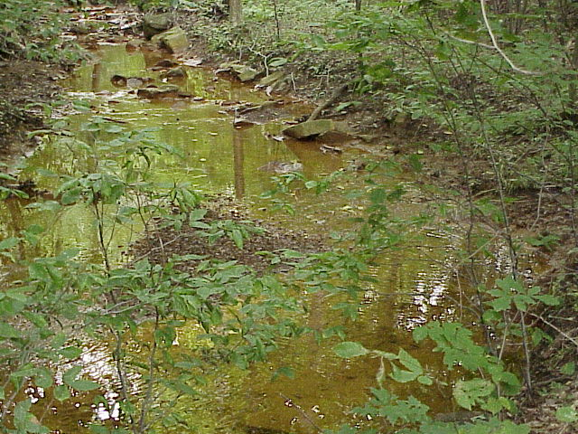

Many of the most valuable coal seams in Somerset County, including the Upper and Lower Freeport and then Upper and Lower Kittanning, are near the surface within the watershed. This easy access made the area a focal point for the extraction of the coal reserves.

The largest producing mine in the Oven Run watershed was the Ralphton #15, which recovered coals from the Lower Kittanning seam. More than 3 million tons of coal was mined during the life of this mine.
Although this and other mines in the watershed are no longer in operation these same locations are now the source of over 720,000 gallons a day of abandoned mine drainage (AMD) that heads directly into the Stonycreek River.

Above Oven Run, the Stonycreek has recovered from AMD pollution to the point that today, a viable trout fishery exists. The Pennsylvania Fish and Boat Commission manages the fishery above Oven Run To Glessner’s Covered Bridge near Shanksville as a put and grow fishery with the stocking of fingerling trout only. The use of fingerling stocking indicates that the Stonycreek above Oven Run supports an aquatic community that can support a healthy and thriving fishery.
The angling on the upper Stonycreek has been well acclaimed and documented in state and national magazines such as the PA Angler and Boater and Fly Fisherman magazine. The upper river is also detailed in angling books such as Charlie Meck’s “PA Trout Streams and their Hatches” and the “Mid Atlantic Budget Angler” by Ann McIntosh. However, the mouth of Oven Run has been labeled ”the beginning of the end of the Stonycreek River.”

In 1990, with the formation of the Stonycreek-Conemaugh River Improvement Project (SCRIP), a coordinated effort began to focus on the methods that could be successful in abating the AMD problems in the Oven Run watershed and restoring as many as 10 miles of the Stonycreek River. The development of public-private partnerships through SCRIP allowed for a variety of organizations to work in partnership with each other and made a project the magnitude of Oven Run finally feasible.

In 1992, at the urging of SCRIP, the Somerset County Conservation District began to develop a proposal through the Soil Conservation Service, now the USDA Natural Resources Conservation Service (NRCS), to create a funding mechanism through the PL-566 watershed program.

Previously funding from this program had never gone toward AMD abatement. The proposal to utilize the program for passive treatment of the major discharges in the Oven Run and Pokeytown Run watersheds was approved and the Oven Run Project was formally created.

With the inclusion of additional partners such as the Pennsylvania Department of Environmental Protection Bureau of abandoned Mine Reclamation (PA DEP BAMR), U.S. Congressman John Murtha, the Southern Alleghenies RC&D and Conservancy, Mountain Laurel Chapter of Trout Unlimited, Somerset County Commissioners and other agencies and organizations 6 sites where identified where treatment systems would be constructed. The estimated cost to complete all 6 sites was estimated to be 5 million dollars.

In 1995 the first site was completed at Site D (Oak Trail) to treat a 90 GPM
Discharge of AMD impacting the Stonycreek River. Acid levels in the discharge range from 100 to 150 milligrams per liter, iron levels average 40MG/L and aluminum levels fluctuate between 1 and 5 MG/L. The pH entering the treatment system is a 3.5.

The treatment system constructed consists of a settling pond that provides oxygen and detains water long enough to begin the precipitation of iron and aluminum. The next feature is a cattail wetland that continues to filter out the metals and add alkalinity. The next treatment cell is a successive alkalinity producing system (SAPS). This area has limestone rock and compost in the bottom that the water flows through.

The compost chemically alters the iron and allows the acid to react with the limestone and neutralize the acid. When the acid is neutralized the water can no longer hold the dissolved metal and they drop out. The water then enters a settling pond for the remaining iron and aluminum to settle out.
A second system of wetlands and SAPS provides the final treatment.

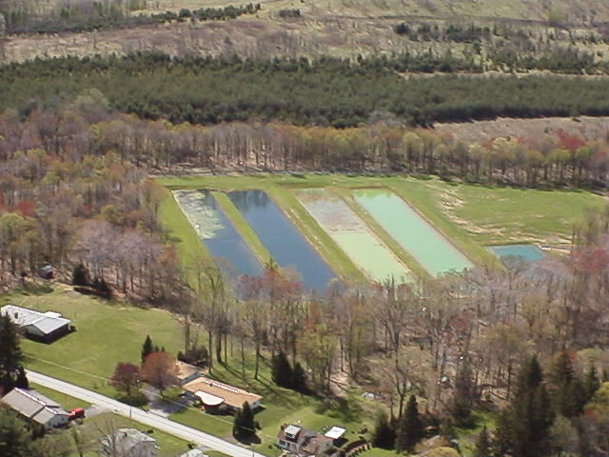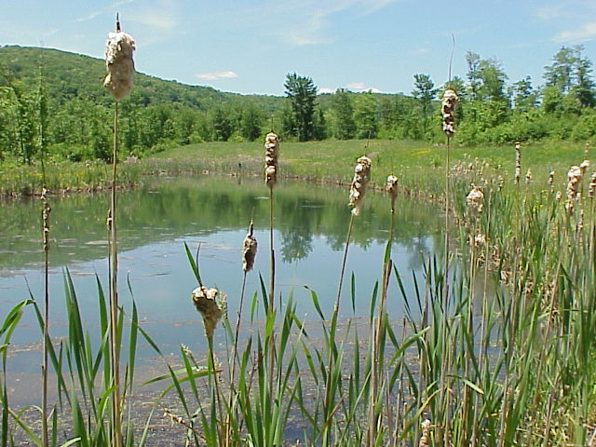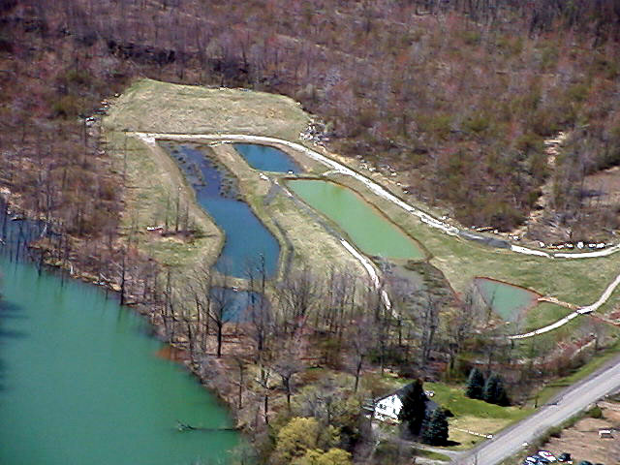

The system removes 96% of all metals and increases the pH level to a high of 7.2. The site, which is owned by the Somerset County Conservancy, also includes a self-guided interpretive trail. Interpretive signage explains how the system functions and details other information about the AMD abatement efforts occurring in the region. The Mountain Laurel Chapter of Trout Unlimited provided half of the funding and the volunteer labor for the trail and secured a grant from National Trout Unlimited’s Embrace-A-Stream Program for the balance of the cost.

Site E was completed in 1997 with passive treatment technology designed to treat a 150 GPM flow near the village of Wilbur. This system treats the water flowing into Pokeytown Run. Site F (Hawk View) was completed in 2000 and treats a 350 GPM flow of AMD on property that was acquired by the Somerset County Conservancy in order for the project to occur. The water treated at this discharge is the worst in the entire Stonycreek watershed.

The pH enters the system at 2.8 with 30MG/L of iron, 20 MG/L of aluminum and a total acidity of 270MG/L. Site B and C (Mountain View) completed in 1999 and 2000 were designed, constructed and funded by the PA DEP Bureau of Abandoned Mine Reclamation. The site C discharge was actually eliminated by backfilling an abandoned highwall, installing surface water controls and stabilizing the 37-acre site. The site B discharge is treated in what may be the largest single surface area treatment system constructed in Pennsylvania.

The Somerset County Conservation District received $400,000.00 in Pennsylvania DEP Growing Greener funds that will provide half of the required funding to treat the site. Site A was completed in 2002 and is now treating from 200 to 300 GPM of mine drainage from the base flow of Oven Run. With all 6 sites completed the cumulative impact is that 800 to 900 tons of acidity, 200 tons of iron and 200 tons of aluminum are being removed from the Stonycreek River each year.

During the summer of 2000 SCRIP volunteers who monitor the Stonycreek River, began to recognize a major change in both Ph and alkalinity levels downstream of the Oven Run sites. The data was compared with baseline data collected in 1992 by the U.S. Geological Survey team. Sampling at the village of Blough, Carpenters Park and the Riverside Bridge, a mile from the city limits of Johnstown, all demonstrated drastic improvement with readings that had been in the 3’s and 4’ now reading in the 5’s and 6’s.

The result is that the Stonycreek River has been transformed from a net acidic waterway to a net alkaline stream. Even more impressive is that all the samples taken at each site showed some alkalinity. This indicates that the AMD still entering the Stonycreek from Shade and Paint Creeks is not enough to use up all the alkalinity now being put into the river through the Oven Run Project.

This historic positive water quality impact demonstrates the power of public-private partnerships developed and pioneered by SCRIP. The ability of diverse organizations working together for a common cause has created a dramatic improvement in the water quality of the Stonycreek watershed. Although the efforts throughout the watershed are not complete the Oven Run Project stands as a testimony to perseverance and dedication of volunteers and professionals alike and points the way toward even more successes.

