Dark Shade Creek

Industrial Past – Bright Future
____________________________________________________________________________________

The Dark Shade Creek Watershed is located in Somerset County at the headwaters of the Stonycreek River Basin. A trip through the Dark Shed watershed presents a traveler with the stunning beauty of remote forested highlands and the historic remains of 200 years of industrialization.

The east section of the watershed extends out to the end of the Allegheny Plateau, which is home to wooded state game lands and a meandering native trout stream, Beaverdam Run.

The central region of the watershed is home to the communities of Central City and Cairnbrook. The village of Cairnbrook is a well preserved relic of the region’s coal mining history. Cairnbrook is located south of SR 160 and is on the National Register of Historical sites because it is a rare example of a well-preserved Appalachian mining community and industrial mining complex.

The northeast corner of the Dark Shade watershed borders the site of the Shade Iron Furnace built in 1807. Nearby are the remains of an old grist mill and the sturdy stone foundations left from a logging settlement not reclaimed by a hemlock forest.

The Dark Shade watershed also bears witness to a grassroots efforts to clean up one of Appalachia’s worst abandoned mine drainage (AMD) impacted waterways. Local participation through the watershed assessment and planning process, in addition to some of the newest and most innovative AMD treatment technologies, are making Dark Shade a cleanup model for the rest of Appalachia.

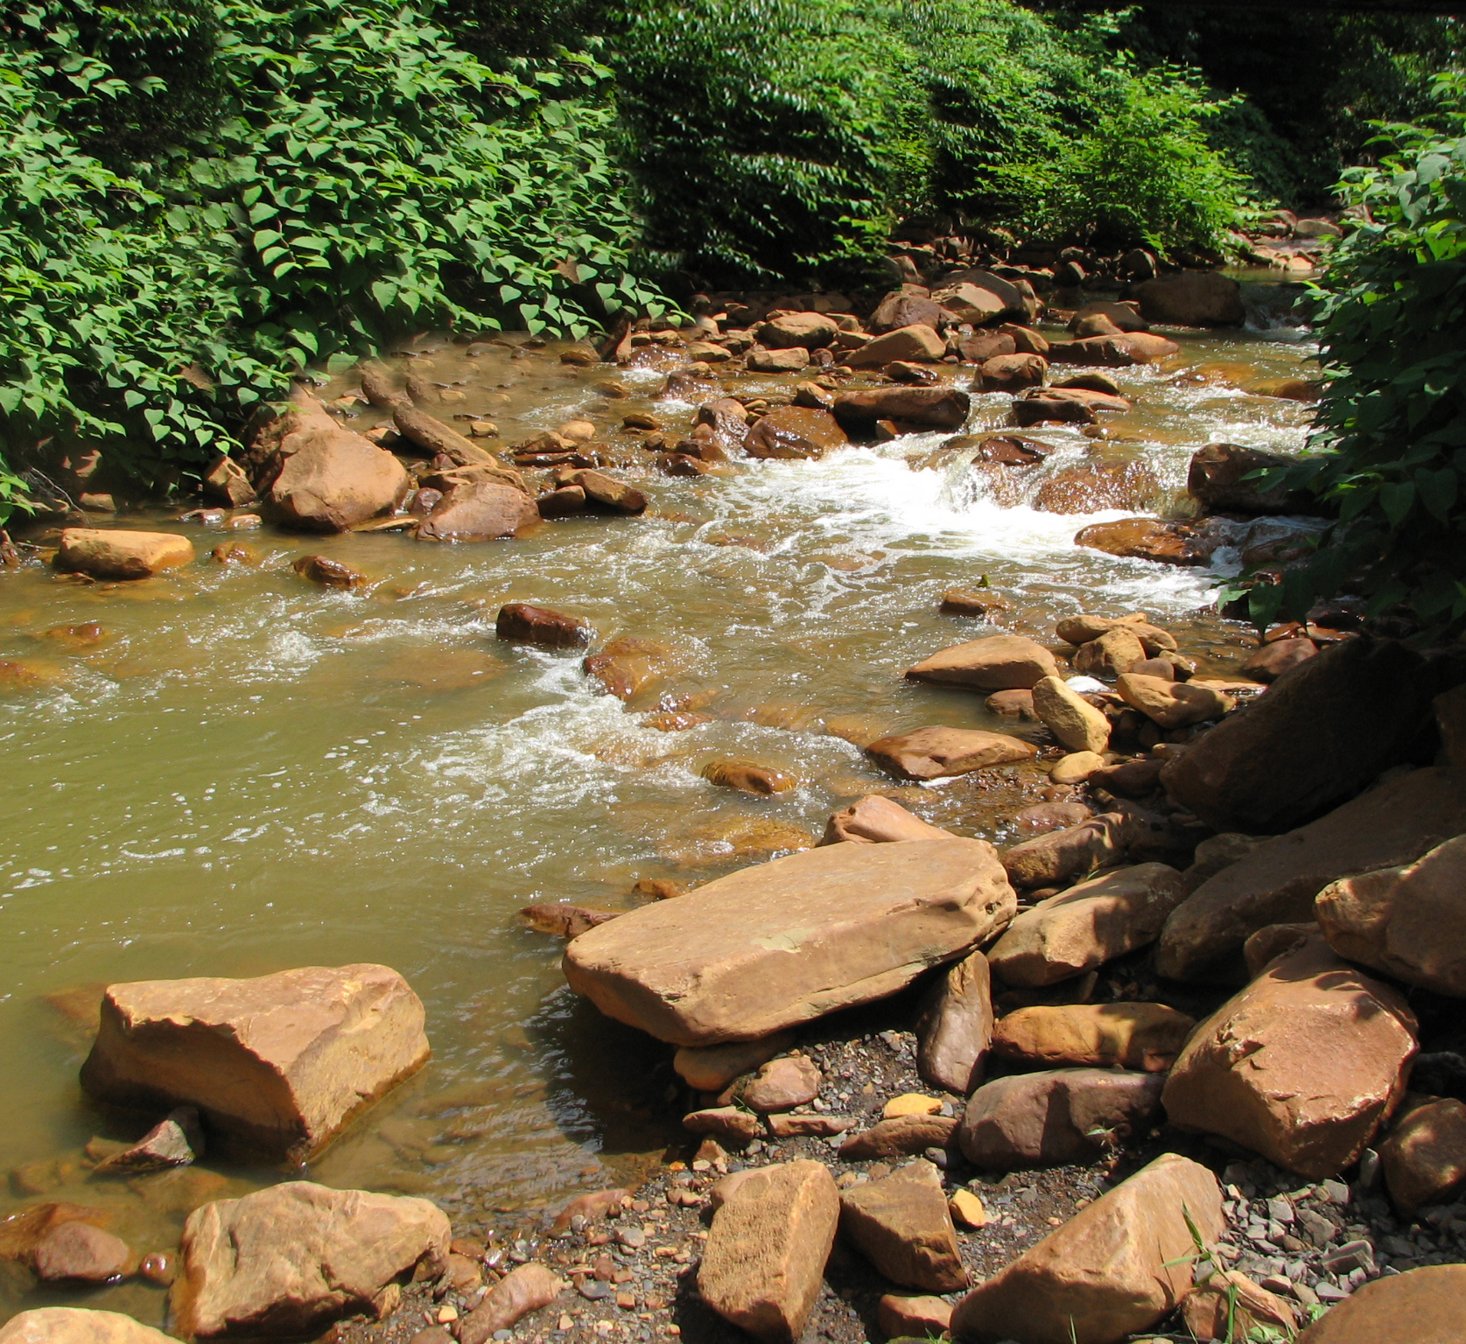

Industrial Past
The region has hosted three extractive industries over the past 200 years—iron ore, timber and coal. Iron ore was mined and forged at the Shade Iron Furnace. The Shade Furnace opened in 1807 and was the first such furnace in Somerset County.

The largest industry at the close of the 19th century was timbering. Dark Shade harbored large stands of eastern hemlock and hardwoods, such as sugar maple, beech, red oak and black cherry. These towering virgin tree stands inspired the early settlers to call the region Dark Shade. The majority of Dark Shade’s ancient timber stands were cut by 1913.

The wealthiest industry in the Dark Shade watershed was coal extraction. Area geology formed widespread outcroppings of coal. The coal extractive industry began on a large scale in 1912 with the opening of the Loyalhanna Coal and Coke Company at the village of Cairnbrook. In 1919 the Reitz Coal Company opened several mines in and around the town of Central City. These mining communities prospered throughout the first half of the twentieth century. By 1957, however, the last major coal company closed down.

The economic boom created by the extractive industry took a heavy toll on the natural environment of Dark Shade Creek. The area was left with abandoned mine lands and acidic mine drainage polluted waterways.

Acid Mine Drainage (AMD)
AMD forms when minerals deep below the earth’s surface are disturbed by mining or some similar activity. The disturbance exposes rock to the air and water causing metals and sulfur held within the rock to leach out. The AMD may flow out in tiny seeps or flow out at the rate of thousands of gallons per minute. AMD is often highly acidic (similar to vinegar) and contains metals such as iron, aluminum and manganese. The highly acidic, metallic water will no longer support aquatic life.

Studies initiated by the Stonycreek Conemaugh River Improvement Project (SCRIP) identified and analyzed all AMD discharges in the 466 square mile Stonycreek River Basin. The largest and most damaging AMD source identified is located in the Dark Shade sub-basin. The discharge is located behind the firehouse in Central City and flows out at 3,000 gallons per minute, carrying acidic, metals-laden water directly into Dark Shade Creek. If the Central City discharge along with other significant discharges in the Dark Shade watershed are treated, aquatic life will return to Dark Shade Creek, Shade Creek and a significant section of the Stonycreek River.

Bright Future
Today Dark Shade’s environment is on the road to recovery following a century of unsustainable use. Scenic forest stands now cover the ridge tops of the Allegheny Mountains and stream valleys, providing hunting and hiking areas. Headwater streams are home to naturally reproducing brown and brook trout. Though nature has been able to heal many of the scars left by industry, the constant flow of AMD into Dark Shade Creek still remains. Local residents and organizations are joining together to clean up abandoned mine lands and acid mine drainage in the Dark Shade watershed.

SCRIP is now finishing a major remediation project to clean up six AMD discharges on Oven Run, which enters the Stonycreek River seven miles upstream of Shade Creek. Dark Shade is the next target for SCRIP’s top down remediation effort on the Stonycreek River. Remediating AMD in Dark Shade Creek will enable the creation of a bass fishery on the Stonycreek River.

Many unique partners have joined SCRIP in their effort to cleanup Dark Shade. One such organization is AMD & ART, who initiated local involvement effort including the communities of Shade Township and Central City Borough. With AMD & ART assistance, communities of the Dark Shade watershed were awarded an Environmental Protection Agency (EPA) Brownfields Redevelopment Grant. This was the first time a watershed was designated as a Brownfield. The EPA Brownfields Projects provides Central City and Shade Township with the opportunity to develop a plan to clean up old abandoned mine lands and AMD discharges in the Dark Shade watershed. The Department of the Interior Office of Surface Mining (OSM) is providing a project advisor to assist the EPA with the Brownfields Project. The Dark Shade Brownfields project is a potential model for revitalizing the communities and environment of AMD impacted watersheds throughout Appalachia.

These committed partnerships eager to clean up the Dark Shade watershed are fueled by a desire to improve the health and natural habitat of the region’s waterways and to unleash the economic benefits of clean streams and rivers. If water quality in Dark Shade watershed is improved, the following water use potentials will be possible:

Fishing—The Dark Shade tributaries of Little Dark Shade Creek and Beaver Dam Run support native and stocked trout. Due to AMD pollutants, the main stem of Dark Shade Creek supports very little aquatic life. Shade Creek that enters the Stonycreek River at Seanor can be as acidic as vinegar and supports almost no aquatic life. Treating priority AMD discharges in the Dark Shade Creek watershed will create a continuous trout fishery from the headwaters of Dark Shade Creek through the scenic Stonycreek River Canyon.

White Water Rafting—Despite AMD pollution, canoeists and kayakers float down Dark Shade and Shade Creek during periods of high flow. The last two miles of Dark Shade are a very steep and dangerous course with Class 4 and Class 5 rapids, which in the region is considered second only to Paint Creek in difficulty. Shade Creek is an 11 mile Class 3 run that empties into the Stonycreek River just above the Class 3 and 4 rapids of the Stonycreek River Canyon. The white water trek from Dark Shade Creek through the Stonycreek River Canyon is the proposed site for a white water park. This park could rival that of Ohiopyle, which receives 5 million dollars a year in tourism.

Border Dam—Recreational opportunities and improved aquatic habitat are not the only incentives driving the cleanup of dark Shade Creek. Border Dam, a low head wooden dam built on the Stonycreek River in 1908 could potentially provide the Cambria and Somerset County regions with 25 million gallons of water daily. Due to poor water quality (mostly from Dark Shade Creek) the dam has not been used for 50 years. Treating priority AMD discharges in Dark Shade Creek will enable border Dam to once again supply industrial grade water to the region.

Local Initiative—Residents of the Dark Shade watershed living in communities of Shade Township and Central City have formed the Shade Creek Watershed Association (SCWA). SCWA has begun a water monitoring program for the Shade Creek Basin. SCWA volunteers take water samples at strategic points throughout the watershed in order to gain a better understanding of the effects of AMD on Dark Shade Creek. SCWA, the Central City Brownfields Project and the Somerset Conservation District have put together the Dark Shade Watershed Restoration Plan. The watershed plan provides a detailed plan for restoring and protecting the Dark Shade Creek watershed.

There are over 20 AMD discharges in the Dark Shade watershed. Treating these discharges will require the best in AMD treatment technology and a very creative and collaborative cleanup effort. Smaller AMD discharges may be treated using a series of wetlands containing compost and limestone. This form of treatment is called passive treatment. Some AMD discharges may be permanently cleaned up by removing coal refuse piles or remining old deep mines and removing the acid causing spoil at its source. SCWA is finishing construction of an AMD treatment system at the headwaters of Dark Shade Creek along the tributary stream, Coal Run. The Coal Run discharge is being treated with an AMD passive treatment system.

Resource Recovery—A resource recovery AMD treatment system neutralized the AMD discharge and removes metals such as aluminum and iron from the water. The metals are then processed and sold. Money from the sale of the metals can be used to pay for maintaining the AMD treatment system.

Resource metals recovery could have potential for AMD discharges that have a high metal content. The Central City discharge expels over 450 pulds of aluminum per day into Dark Shade Creek. This is the highest aluminum discharge in the Stonycreek River watershed. A prototype is now being designed to recover aluminum from the Central City discharge and treat the discharge water.

For more information on the SCWA or the Dark Shade Brownfields Project please call (814) 754-5953.

