Bens Creek

Wilderness – Wild Trout – Wild Water
____________________________________________________________________________________

Deep in the mountainous terrain of the eastern slope of the Laurel Mountain lie the origins of the Bens Creek. The South and North Forks of Bens Creek, both located in Somerset County, are the primary tributaries of the main stem of the Bens Creek.

The South Fork, which encompasses the Conemaugh Township Reservoir utilized as a drinking water supply, flows 12 miles mostly through steep valleys, while the North Fork flows five miles and encompasses the North Fork Reservoir operated by the Johnstown Water Authority.

Both the North and South Forks were originally designated as High Quality cold water fisheries. At the request of the PA Fish and Boat Commission (PFBC) the South Fork, North Fork and two tributaries to the North Fork Reservoir, Allwine and Riffle Runs, were evaluated for redesignation as Exceptional Value. On December 15, 1992 the Environmental Quality board upgraded the upper portions of both the North and South Forks, as well as Allwine and Riffle Runs to Exceptional Value. This was in part due to the documentation of wild reproducing rainbow trout on the North Fork, Allwine and Riffle Runs. Wild rainbows are also found on the South Fork above the Conemaugh Township Water Authority impoundment. Reproducing stocks of rainbow trout are extremely rare in Pennsylvania and their existence demonstrates the excellent water quality found in both headwater basins.

The headwaters of both the North and South Forks lie in difficult to access mountainous regions. State Route 0271 crosses the headwaters of the North

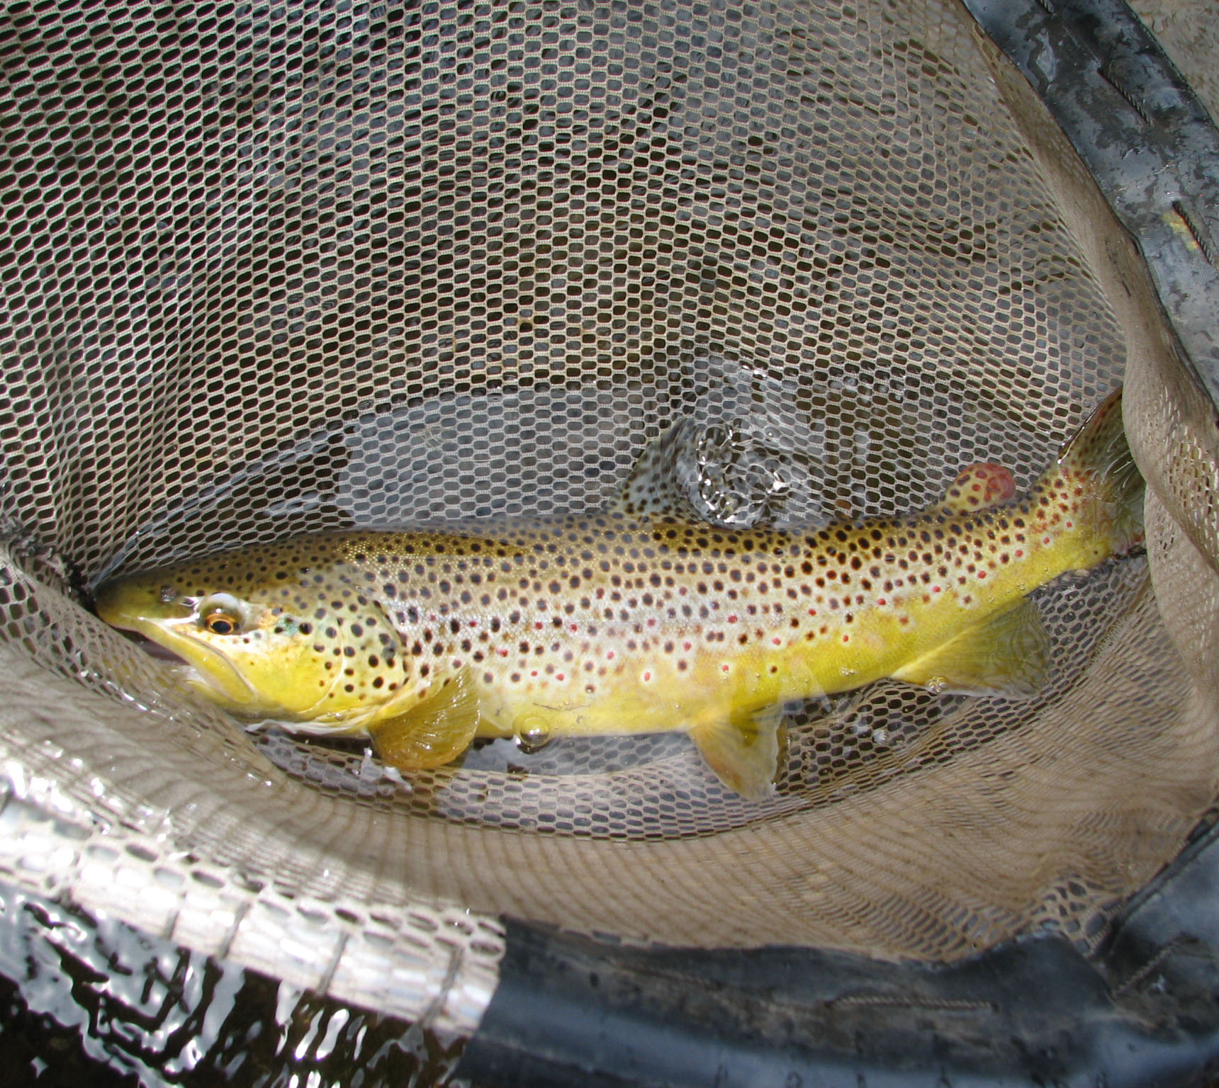
A Bens Creek brown trout
Photo by Lenny Lichvar

Fork and Township Route 534 parallels the South Fork for a distance. Otherwise access is limited to water authority maintenance roads and jeep trails which entail walk in access only.

Although the water quality in both the North and South Forks allow for resident wild populations of trout, including brown and brook trout in the section below the reservoirs, the waters are also poorly buffered freestone streams. This makes them highly susceptible to acid rain, which is a documented, major problem on the Laurel Ridge. Fortunately, the forested region through which both branches flow helps to keep the water temperature cool and relatively stable, maintaining an overall habitat conducive to fish propagation and existence.

Investigation by DEP's Bureau of Water Quality Management has also revealed positive evidence of healthy populations of diverse benthic macroinvertebrate communities. Allwine Creek possesses 35 taxa, Riffle Run 32 taxa, the North Fork 28 taxa and the South Fork 30 taxa. Although
the densities of each taxa are not high, the
diversity of the taxa are typical of what is

required to have an exceptional quality freestone stream. The South Fork, after exiting its more remote sections, enters a more populated region consisting of residential houses along Route 985 as it flows north toward its confluence with the North Fork that creates the main stem of the Bens Creek.

The upper portion of the South Fork has been stocked by the PFBC with brook, brown and rainbow trout since the 1940's. Currently, the Greater Ferndale Sportsman's Club also supplements this stocking with their own plantings each year.

However, in the vicinity of Thomas Mills mine drainage becomes the first sign of man's negative impact on the South Fork. There are several deep mine discharges left from abandoned mine operations dating back to the first half of this century. The smaller discharges have low pH's, high iron contents and large amounts of acidity. The major source, however, is nearly neutral in pH and relatively low in iron since the alkaline discharge causes the metals to drop out quickly after the water exits into the creek. Unfortunately, this can cause a red carpet of ferric hydroxide that smothers aquatic insect life making survival of fish in the affected area impossible because of the lack of a food source.

For many years the entire section of the South Fork below this alkaline discharge was not stocked with fish because of the assumption that the water was too polluted to support the trout. Ironically, a coal company survey in 1976 determined that the iron
content of the discharge settled out after about two miles and that the
South Fork below that point held a somewhat stable and recovering insect population. Once this information was brought to the attention of then PFBC Fisheries Biologist Blake Weirich, an experimental stocking of 500 fish was commissioned. That stocking proved to be a success and the lower portion of the South Fork and the main stem have been stocked heavily with trout each year since. In addition, the trout that are stocked each spring have been able to hold over throughout the year providing for a year round viable trout fishery all the way to the mouth of the Bens Creek.

However, the alkaline discharge near Thomas Mills, which has come to be known as Rock Tunnel, continued to be a constant problem as far as water quality was concerned. Fortunately, for the creek and its recreational users, this site, which has tainted the South Fork for many years, was remediated during the summer of 1994 through the networking efforts of the Stonycreek-Conemaugh River Improvement Project (SCRIP) and cooperative efforts from the Somerset Conservation District and Lion Mining. A passive treatment system consisting of holding ponds and connecting trenches was installed, which now essentially eliminates the last major source of mine drainage into the South Fork. The Pennsylvania DEP is scheduled to rectify an additional site upstream from Rock Tunnel in the near future. These projects will eventually resurrect a once dead section of the South Fork and allow water to flow relatively untainted downstream to its conflux with the North Fork.

Also during the summer of 1994 the PFBC surveyed the South Fork to determine what changes had taken place in the fish population since the last survey in 1987. It was determined that the South Fork is a class B stream with 20 - 40 pounds of wild trout per acre. According to current Area Fisheries Biologist Rick Lorson, this is above average for what is generally regarded as a stocked trout stream.

The downside is that the total population of trout was somewhat lower than found in 1987. This could have been caused by heavy spring rains and higher than normal flows, which may have caused mortality in many of the young fish during the past several springs.

The other detraction to this section of the South Fork and to the main stem as well is a lack of suitable holding water. Both PFBC personnel and area sportsmen believe that the addition of suitable holding water would greatly increase the number of holdover, wild and stocked fish throughout the Bens Creek.

With this in mind the Mountain Laurel Chapter of Trout Unlimited has implemented numerous stream enhancement projects that have increased the type of structured holding water required by trout for increased survival. This effort coupled with the current efforts to reduce mine drainage problems is greatly enhancing the Bens Creek's role as an outstanding recreational resource.

In addition to its past and future importance as a viable fishery, the Bens Creek has garnered a reputation, especially in early spring as an excellent location for rafting and canoeing. The Bens Creek Canoe Club holds canoe races on the stream and recently marked its 20th anniversary race in 1992. The race is usually the earliest of its kind held in Pennsylvania each year. The utilization of the Bens Creek in this manner brings participants from outside the local region and offers an opportunity for the public to better understand the multiuse recreational capacity that exists in the stream.

As the main stem of the Bens Creek heads toward Johnstown and its confluence with the Stonycreek River, it meanders through a more urban setting. This section of the creek is also surrounded by the rich industrial and historical heritage of the area. Some of the first iron furnaces in the region dating back to the 1840's were constructed near the villages of Benscreek and Millcreek. Pig iron produced at these furnaces was floated on rafts down the Bens Creek and then the Stonycreek on their way to Johnstown and Pittsburgh.

A regionally significant 45 acre recreational facility known as Ideal Park once sat on the shores of the Bens Creek where thousands of people came to recreate during the 1920's and 30's. Although not in use today, the park once boasted of having the largest swimming pool in North America measuring 300 feet by 600 feet.

The lower end of the Bens Creek has also fallen victim to the floods that encompass the history of the Johnstown area. Although much of the focus of these disasters went elsewhere, residents and the structures they erected at the lower reaches of the stream suffered mightily from the numerous floods that have befallen the region.

Actually the flooding of the lower Bens Creek is a distinct and tragic side note to what can occur when man interferes with the natural environment without much forethought. The St. Andrews Church and a shopping center, both situated along the Bens Creek, were built on filled in wetlands adjacent to the mouth of the stream. When nature's own flood controls are infringed upon by man a high price can and usually will be extracted.

All considered however, the Bens Creek and its tributaries have faired better than many of its counterparts in southwestern Pennsylvania. Its headwaters exist today much as they have for centuries. The construction of reservoirs on the branches has aided in economic development, but have not had negative effects on the streams. Although tainted by mine drainage, the Bens Creek has survived as a fishery throughout a period when many streams of similar origin and location have been completely decimated. Even by flowing through more densely populated regions, the Bens Creek has afforded recreational opportunities to the masses while retaining its natural and physical characteristics which has made is so unique.

